|  |  |  |  |
| --- | --- | --- | --- |
| logofire-standardresolution | jaune | logo_ce-en-rvb-hr | 7plogo |

|  |  |
| --- | --- |
| Project Acronym | **Fed4FIRE** |
| Project Title | **Federation for FIRE** |
| Instrument | **Large scale integrating project (IP)** |
| Call identifier | **FP7-ICT-2011-8** |
| Project number | **318389** |
| Project website | **www.fed4fire.eu** |
| Experiment | **GEO-Cloud** |

**Detailed Design Report**

|  |  |
| --- | --- |
| Work package | WP10 |
| Task | T10.1.2 GEO-Cloud Experiment |
| Due date | 10/01/2014 |
| Submission date | 10/01/2014 |
| Report Lead | Félix Pedrera (DEIMOS) |
| Version | 1.0 |
| Authors | Manuel José Latorre, Antonio Serrano Gómez, Félix Pedrera, Gerardo González, Jonathan Becedas (DEIMOS) |
| Reviewers | Jonathan Becedas (DEIMOS) |

|  |  |
| --- | --- |
| **Document ID** | **GEO-Cloud-D10.8** |
| Abstract | This document provides technical information about the GEO-Cloud experiment detailed design |
| Keywords | Deliverable |

|  |  |  |  |
| --- | --- | --- | --- |
| Nature of the document | R | Report | X |
| P | Prototype |  |
| D | Demonstrator |  |
| O | Other |  |
| Dissemination level | PU | Public |  |
| PP | Restricted to other programme participants (including the Commission) |  |
| RE | Restricted to a group specified by the consortium (including the Commision) |  |
| CO | Confidential, only for members of the consortium (including the Commission) | X |

**Disclaimer**

*The information, documentation and figures available in this deliverable, is written by the Fed4FIRE* (Federation for FIRE) *– project consortium under EC co-financing contract FP7-ICT-318389 and does not necessarily reflect the views of the European Commission. The European Commission is not liable for any use that may be made of the information contained herein.*

**Executive Summary**

In this document the detailed design of the GEO-Cloud experiment is presented. The document is divided into 7 sections:

Section 1 introduces the document.

Section 2 is devoted to the design of the satellite system. It is constituted by the design of a constellation of 17 satellites and 12 ground stations. The satellites share the same orbit and take a world land surface image on a daily basis. All the data generated is then downloaded to the ground stations network.

Section 3 presents the scenarios to be tested in the experiment. 6 use cases will be tested, although 11 were designed for its possible implementation during the next stages of the experiment. Those use cases are described in the Appendix included as Section 9.

Section 4 describes the image distribution and visualization to provide services through the BonFIRE cloud.

Section 5 is devoted to the design of the architecture to be implemented in BonFIRE, the processing chain of the satellites’ images and the distribution of the the image explained in Section 4. A first approach of the resources that will be used in BonFIRE is included.

Section 6 shows the design of the part of the experiment that will be implemented in Virtual Wall and the connectivity required with BonFIRE. A first approach of the resources that will be used in Virtual Wall is included.

Section 7 is devoted to the design of the experiment that will be implemented and tested in PlanetLab Europe. A first approach of the resources that will be used in Virtual Wall is included.

Section 8 presents the cited bibliography throughout the text.

**Acronyms and Abbreviations**

|  |  |
| --- | --- |
| AOI | Area of Interest |
| API | Application Programming Interface |
| BF | BonFIRE |
| CDN | Content Delivery Network |
| CPU | Central Processing Unit |
| CSW | Catalogue Services for the Web |
| EaaS | Elasticity as a Service |
| EO | Earth Observation |
| ESDI | European Spatial Data Infrastructure |
| EUROGI | European Umbrella Organization for Geographic Information |
| EUROSUR | European Border Surveillance System |
| FGDC | Federal Geographic Data Committee |
| FTP | File Transfer Protocol |
| GIS | Geographic Information System |
| GMES | Global Monitoring for Environment and Security |
| GPS | Global Positioning System |
| GPU | Graphics Processing Unit |
| GQ | Golden Quadrilateral |
| GS | Ground Station |
| GSD | Ground Sample Distance |
| HMA | Heterogeneous Missions Accessibility |
| HPC | High Performance Computing |
| HTTP | Hypertext Transfer Protocol |
| INSPIRE | Infrastructure for Spatial Information in Europe |
| ISO | International Organization for Standardization |
| KML | Keyhole Markup Language |
| L0 | Level 0 processor |
| L1A | Level 1 A processor |
| L1B | Level 1 B processor |
| L1C | Level 1 C processor |
| LEO | Low Earth Orbit |
| LTAN | Local Time of Ascending Node |
| NASA | National Aeronautics and Space Administration |
| NHAI | National Highways Authority of India |
| OGC | Open Geospatial Consortium |
| PNOT | Plan Nacional de Observación del Territorio (Spanish Plan of Territory Observation and Urbanism) |
| PNT | Plan Nacional de Teledetección (Spanish Plan of Remote Sensing) |
| PP | Product Processor |
| RDBMS | Relational Database Management System |
| REST | Representational State Transfer |
| Sat | Satellite |
| SCO | Snow Cover Area |
| SDI | Spatial Data Infrastructure |
| SFTP | Secure File Transfer Protocol |
| SOA | Service Oriented Architecture |
| SQL | Structured Query Language |
| SSO | Sun-Synchronous Orbit |
| SWE | Snow Water Equivalent |
| TBD | To be defined |
| TMS | Tile Map Service |
| UAV | Unmanned Aerial Vehicle |
| VM | Virtual Machine |
| VW | Virtual Wall |
| WCS | Web Coverage Service |
| WFS | Web Feature Service |
| WMS | Web Map Service |
| WMS-C | Web Map Tile Caching |
| WMTS | Web Map Tile Service |
| WPS | Web Processing Service |
| WS | Web Service |
| XML | eXtensible Markup Language |

**Table of Contents**

[1 Introduction 11](#_Toc381777184)

[2 Satellite System Design 12](#_Toc381777185)

[2.1 Design of the flight and ground segments 12](#_Toc381777186)

[2.1.1 Global Daily Coverage 12](#_Toc381777187)

[2.1.2 Flight Segment 13](#_Toc381777188)

[2.1.3 Ground stations design 16](#_Toc381777189)

[2.2 Generated Data Volume 17](#_Toc381777190)

[2.3 Summary 18](#_Toc381777191)

[3 Scenarios definition and users’ model design 20](#_Toc381777192)

[3.1 Scenarios 22](#_Toc381777193)

[3.1.1 Scenario 1: Emergencies - Lorca Earthquake (Spain) 22](#_Toc381777194)

[3.1.2 Scenario 2: Infrastructure monitoring. Affection in railway infrastructures by sand movement in desert areas (Spain) 26](#_Toc381777195)

[3.1.3 Scenario 3: Land Management – South West of England 29](#_Toc381777196)

[3.1.4 Scenario 4: Precision Agriculture - Argentina 32](#_Toc381777197)

[3.1.5 Scenario 5: Basemaps – Worldwide 35](#_Toc381777198)

[3.1.6 Scenario 6: Online Catalogue / Ordering – Worldwide. 38](#_Toc381777199)

[3.2 Summary 41](#_Toc381777200)

[4 Imagery distribution and visualization system design 42](#_Toc381777201)

[4.1 Concepts and evolution of imagery distribution and visualization 42](#_Toc381777202)

[4.1.1 Interoperable Earth Observation imagery delivery: Spatial Data Infrastructures 42](#_Toc381777203)

[4.1.2 Demand-driven Earth Observation images delivery 43](#_Toc381777204)

[4.2 Geo-Cloud Image Distribution and Visualization System (Geo-Cloud IDV) design 44](#_Toc381777205)

[4.2.1 Distribution and Visualization mechanisms for Geo-Cloud IDV 45](#_Toc381777206)

[4.2.2 Geo-Cloud IDV Architecture 51](#_Toc381777207)

[4.3 Summary 54](#_Toc381777208)

[5 Data processing and storage in BonFIRE 55](#_Toc381777209)

[5.1 Architecture 55](#_Toc381777210)

[5.2 Orchestrator 58](#_Toc381777211)

[5.3 Product Processors 59](#_Toc381777212)

[5.3.1 The L0 processor 61](#_Toc381777213)

[5.3.2 The L1A processor 62](#_Toc381777214)

[5.3.3 The L1B processor 62](#_Toc381777215)

[5.3.4 The L1C processor 63](#_Toc381777216)

[5.4 Archive and Catalogue 63](#_Toc381777217)

[5.5 Imagery Distribution and Visualization 64](#_Toc381777218)

[5.5.1 Archive and Catalogue 64](#_Toc381777219)

[5.5.2 Datastore 65](#_Toc381777220)

[5.5.3 EO Server 65](#_Toc381777221)

[5.5.4 Tiles Caches 65](#_Toc381777222)

[5.6 Data, control and monitoring parameters 66](#_Toc381777223)

[5.6.1 Data 66](#_Toc381777224)

[5.6.2 Control parameters 66](#_Toc381777225)

[5.6.3 Monitoring parameters 66](#_Toc381777226)

[5.7 Data flow and configuration of the nodes 66](#_Toc381777227)

[5.8 Summary 67](#_Toc381777228)

[6 Topology Networks in Virtual Wall 68](#_Toc381777229)

[6.1 Architecture 68](#_Toc381777230)

[6.2 Layer 1 69](#_Toc381777231)

[6.3 Layer 2 71](#_Toc381777232)

[6.4 Layer 3 72](#_Toc381777233)

[6.4.1 Design of L3 for the pre-defined use cases 73](#_Toc381777234)

[6.5 Updating of the networks parameters 75](#_Toc381777235)

[6.6 Data, control and monitoring parameters 76](#_Toc381777236)

[6.6.1 Data 76](#_Toc381777237)

[6.6.2 Control parameters 76](#_Toc381777238)

[6.6.3 Monitoring parameters 76](#_Toc381777239)

[6.7 Data flow and configuration of the nodes 76](#_Toc381777240)

[6.8 Summary 77](#_Toc381777241)

[7 Network design in PlanetLab Europe 78](#_Toc381777242)

[7.1 Architecture 78](#_Toc381777243)

[7.2 Layer 1 79](#_Toc381777244)

[7.3 Layer 2 82](#_Toc381777245)

[7.3.1 Design for the Scenario 1 Emergencies - Lorca Earthquake (Spain) 83](#_Toc381777246)

[7.3.2 Design for the Scenario 2 Infrastructure monitoring - Affection in railway infrastructures by sand movement in desert areas (Spain) 84](#_Toc381777247)

[7.3.3 Design for the Scenario 3 Land Management – South West of England. 84](#_Toc381777248)

[7.3.4 Design for the Scenario 4 Precision Agriculture – Argentina. 84](#_Toc381777249)

[7.3.5 Design for the Scenario 5 Basemaps – Worldwide. 84](#_Toc381777250)

[7.3.6 Design for the Scenario 6 Online Catalogue / Ordering – Worldwide. 84](#_Toc381777251)

[7.4 Data, control and monitoring parameters 84](#_Toc381777252)

[7.4.1 Data 84](#_Toc381777253)

[7.4.2 Control parameters 85](#_Toc381777254)

[7.4.3 Monitoring parameters 85](#_Toc381777255)

[7.5 Data flow and configuration of the nodes 85](#_Toc381777256)

[7.6 Summary 86](#_Toc381777257)

[8 Bibliography 87](#_Toc381777258)

[9 Appendix: Other scenarios 88](#_Toc381777259)

[9.1 Scenario 7: Maritime surveillance – Alboran Sea 88](#_Toc381777260)

[9.1.1 Scenario description 88](#_Toc381777261)

[9.1.2 Response 88](#_Toc381777262)

[9.1.3 Data distribution 89](#_Toc381777263)

[9.1.4 Area of Interest 89](#_Toc381777264)

[9.1.5 Users 89](#_Toc381777265)

[9.1.6 Service Type 89](#_Toc381777266)

[9.1.7 Processing Level 89](#_Toc381777267)

[9.1.8 Storage Level 89](#_Toc381777268)

[9.1.9 Communications Level 89](#_Toc381777269)

[9.1.10 Demand Variability 89](#_Toc381777270)

[9.2 Scenario 8: Homeland Security - Lisbon 91](#_Toc381777271)

[9.2.1 Scenario description 91](#_Toc381777272)

[9.2.2 Response 91](#_Toc381777273)

[9.2.3 Data distribution 91](#_Toc381777274)

[9.2.4 Area of Interest 91](#_Toc381777275)

[9.2.5 Users 92](#_Toc381777276)

[9.2.6 Service Type 92](#_Toc381777277)

[9.2.7 Processing Level 92](#_Toc381777278)

[9.2.8 Storage Level 92](#_Toc381777279)

[9.2.9 Communications Level 92](#_Toc381777280)

[9.2.10 Demand Variability 92](#_Toc381777281)

[9.3 Scenario 9: Hydrology – Snow, lake cover in Norway 94](#_Toc381777282)

[9.3.1 Scenario description 94](#_Toc381777283)

[9.3.2 Response 94](#_Toc381777284)

[9.3.3 Data distribution 94](#_Toc381777285)

[9.3.4 Area of Interest 95](#_Toc381777286)

[9.3.5 Users 95](#_Toc381777287)

[9.3.6 Service Type 95](#_Toc381777288)

[9.3.7 Processing Level 95](#_Toc381777289)

[9.3.8 Storage Level 95](#_Toc381777290)

[9.3.9 Communications Level 95](#_Toc381777291)

[9.3.10 Demand Variability 95](#_Toc381777292)

[9.4 Scenario 10: Hosting for scientists 97](#_Toc381777293)

[9.4.1 Scenario description 97](#_Toc381777294)

[9.4.2 Response 97](#_Toc381777295)

[9.4.3 Data distribution 97](#_Toc381777296)

[9.4.4 Area of Interest 97](#_Toc381777297)

[9.4.5 Users 97](#_Toc381777298)

[9.4.6 Service Type 97](#_Toc381777299)

[9.4.7 Processing Level 97](#_Toc381777300)

[9.4.8 Storage Level 97](#_Toc381777301)

[9.4.9 Communications Level 97](#_Toc381777302)

[9.4.10 Demand Variability 97](#_Toc381777303)

[9.5 Scenario 11: Piracy – Africa Horn (Somalian Coast) 99](#_Toc381777304)

[9.5.1 Scenario description 99](#_Toc381777305)

[9.5.2 Response 99](#_Toc381777306)

[9.5.3 Data distribution 99](#_Toc381777307)

[9.5.4 Area of Interest 99](#_Toc381777308)

[9.5.5 Users 99](#_Toc381777309)

[9.5.6 Service Type 100](#_Toc381777310)

[9.5.7 Processing Level 100](#_Toc381777311)

[9.5.8 Storage Level 100](#_Toc381777312)

[9.5.9 Communications Level 100](#_Toc381777313)

[9.5.10 Demand Variability 100](#_Toc381777314)

# Introduction

The GEO-Cloud experiment consists of the emulation of a realistic and complete Earth Observation System that provides services using cloud technology. For that purpose a constellation of satellites, ground stations, a cloud architecture, use cases and end users’ models are designed.

The EO system will be computed and emulated in Fed4FIRE: A constellation of satellites record images of the Earth in a daily basis. The images are transferred to ground stations that ingest the data into a cloud computing infrastructure. The data is processed and distributed to end users.

The GEO-Cloud experiment is tested in three testbeds: Virtual Wall, BonFIRE and PlanetLab Europe. GEO-Cloud is divided into two sub-experiments:

* One experiment in a system integrated in Virtual Wall and BonFIRE.
* One experiment in PlanetLab Europe.

The experiment in Virtual Wall and BonFIRE emulates the whole EO system. In Virtual Wall: constellation of satellites, the ground stations and the end users’ models. In BonFIRE the cloud architecture, the processing chain of the data and its distribution. Both Virtual Wall and BonFIRE are interconnected to transfer information from one testbed to the other and viceversa.

The experiment in PlanetLab Europe consists of the emulation of the networks that constitute the links between the ground stations to the cloud and from the cloud to the end users. There, the network performance, features, bandwidth and impairments are monitored and measured. Those parameters once measured are used to update the models implemented in Virtual Wall, i.e, bandwidth, latency, loss rate and background noise.

In the next sections, the detailed design of the GEO-Cloud experiment is introduced.

# Satellite System Design

## Design of the flight and ground segments

In this section, the main characteristics of the system are presented. Objectives, constraints, previous estimations and possible modifications and their effects in the system are exposed.

In a wide vision, it is an **Earth Observation (EO)** system consisting of a constellation of satellites equally spaced in a LEO orbit with the aim of achieving **daily coverage** of the entire Earth surface. These conditions imply a very sophisticated handle of a huge quantity of data.

The following requirements have been fulfilled to design the system:

1. Swath: 160km (based on state of the art cameras).
2. Resolution: 6.7m (based on state of the art cameras).
3. Low Earth Orbits.
4. Sun Synchronous orbits.
5. Download data rate: 160 Mbps (based on Deimos-2 satellite characteristics).
6. Optical Bands: 5 Multispectral (based on state of the art cameras).

### Global Daily Coverage

The objective of this system is the acquisition of images of the total Earth surface in a daily basis. Global coverage is considered to include the land surface that is shown in Figure 1.

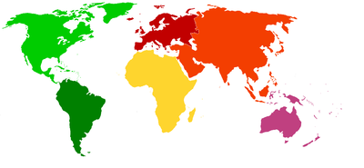

|  |  |  |  |  |
| --- | --- | --- | --- | --- |
| [America](http://es.wikipedia.org/wiki/Am%C3%A9rica) | [Asia](http://es.wikipedia.org/wiki/Asia) | [Europ](http://es.wikipedia.org/wiki/Europa)e | [Africa](http://es.wikipedia.org/wiki/%C3%81frica) | [Oceania](http://es.wikipedia.org/wiki/Ocean%C3%ADa) |

Figure 1. Land surface to be acquired in a daily basis.

This plan of acquisition implies the system to be able of taking a volume of image higher than **135 Millions km2 per day**, as shown in Table 1.

Table . Surface of each continent.

|  |  |
| --- | --- |
| Continent | Surface (km²) |
| [Asia](http://es.wikipedia.org/wiki/Asia) | 43 810 000 |
| [America](http://es.wikipedia.org/wiki/Am%C3%A9rica) | 42 330 000 |
| [Africa](http://es.wikipedia.org/wiki/%C3%81frica) | 30 370 000 |
| [Europ](http://es.wikipedia.org/wiki/Europa)e | 10 180 000 |
| [Oceania](http://es.wikipedia.org/wiki/Ocean%C3%ADa) | 9 008 500 |
| TOTAL | 135 698 500 |

This acquisition plan is used for the mission because it is very demanding in terms of data handling.

*In the experiment we will define scenarios with areas of interest in order to reduce the amount of data processed, stored and distributed through the Fed4FIRE infrastructure.*

### Flight Segment

The satellites are selected according to the current state of the art. However, some enhancements can be assumed as a way to adjust the analysis to the short term future.

#### Satellite performances

As a first iteration for the system, small platforms of less of 500kg are supposed according to the size and payload bay characteristics of representative platforms in this category. This study is based on the bus platforms currently offered by Surrey Satellite Technology Ltd, Satrec Initiative, Sierra Nevada Corporation, etcetera.

To reduce the amount of satellites orbiting the Earth, a design with two payloads has been assumed. Thus, the swath (the width of the field of view of each satellite in the surface of the Earth) can be duplicated without decreasing the resolution.

The satellites shall be **pointing to nadir**, acquiring images without maneuvering because of the acquisition plan for cover the Earth daily. Simultaneously, when a satellite gets into the field of view of a Ground Station, the download starts and at the same time the satellite continues imaging.

The main specifications of the satellites in the constellation are shown in Table 2. The values of each parameter have been selected according to the state of the art and the desired quality of the images in the mission.

Table . Main performances of the satellites.

|  |  |
| --- | --- |
| Specification | Value |
| GSD | 6.7 m |
| Swath | 160 km |
| Number of bands | 5 |
| Digitalization | 12 bits |
| Download data rate | 160 Mbps |
| Compression rate | 2:1 |

*Some options to reduce the acquired data, apart from defining scenarios and areas of interest are the following:*

* *To reduce the resolution by increasing the value of the GSD. This has a strong impact in the quality of the images and therefore in the mission.*
* *To decrease the number of bands, this reduces the spectral information that is acquired in each image.*
* *To change the digitalization of the pixels from 12bits to 8bits, 10bits… which has an impact in the quality of the image too by reducing the information included in each pixel.*
* *To enhance the ratios of compression to reduce the size of the compressed images before the download. 2:1 is an average ratio for lossless compression, but the use of lossy compression (with variable ratios depending on the image) is also extended reaching to ratios up to 100 times of reduction of the original size in the most favorable cases (clouds, sea…).*

*Changes in the swath only affects to the number of required satellites to cover the Earth, as can be seen in Section 2.1.2.3.*

*The download data rate is also an adjustable parameter that affects to the time the satellites have to be downloading the acquired data. If data rate increases, the number of ground stations for the reception of images could be reduced.*

#### Orbit definition

It is common in EO satellite missions the use of **sun-synchronous** orbits. These orbits guarantee that the lighting conditions of the imaged places are the same during the mission, which is a very desirable characteristic.

LTAN (Local Time Ascending Node) is also a desired condition of the orbit very related to the lighting and weather conditions of those places that the satellite overflies (LTAN is selected according to the desired local time of the overflown places and the cloud formation during the day); it is common the use of **LTAN 10:30h** for Earth Observation.

Other of the main parameters of an orbit is the altitude. Altitude has effects in the resolution and the swath of the satellites, which has impact in the number of satellites required to achieve the coverage objective. According to the value of those parameters in the payloads included in the satellites, the reference altitude for the system was found to be **646km**. Sun-Synchronous Orbit (SSO) condition implies a relation between the altitude and the inclination of the orbit of **97.97deg** in this case.

*Changes in the altitude of the orbit have strong effects in main parameters of the mission. When altitude is increased resolution worsens but swath increases too, then the number of satellites could be reduced and the data volume would be lower. Consequently, if the altitude decreases the resolution and the data volume increase whilst the swath is reduced and then more satellites would be required.*

#### Number of satellites in the constellation

In this section, the strategy for covering the Earth in a daily basis is explained. The result of the calculation is the required number of satellites in the orbit and the gap between them in the orbit.

Taking advantage of the geometry that the problem involves, it is easy to achieve a pattern which is repeated in each orbit. This pattern consists of overlapping the swath of each satellite with the swath of the next satellite in the orbit by adjusting the distance between them. In Figure 2 it can be seen the whole pattern, it progresses over the surface of the Earth in consecutive orbits covering it completely in one day.

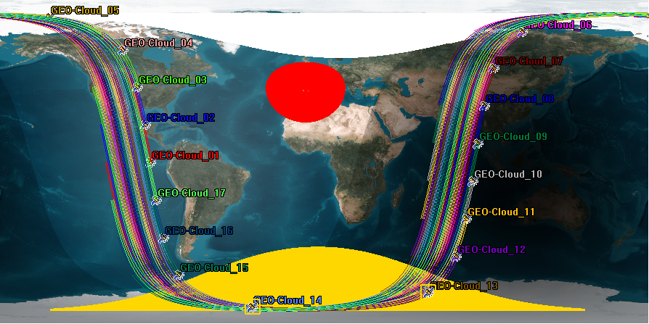

Figure . Pattern of overlapped swaths in one orbit.

The number of satellites and the distance between them shall be calculated from the following inputs in Table 3.

Table . Inputs for the calculation of the the number of satellites.

|  |  |
| --- | --- |
| Inputs | Value |
| Altitude | 646 km |
| Inclination | 97.97 deg |
| Swath | 160 km |

To achieve the overlapped swathes in a SSO, the satellites shall be placed taking into account that the Earth rotates a distance between passes over the equator of consecutive satellites that makes their swaths overlap. At higher latitudes, the swaths are more overlapped and this is why the equator is the most restrictive case and where the calculations are made. For these orbits and swath, the number of satellites obtained to carry out this mission is 17, (see Table 4).

Table . Required number of satellites.

|  |  |
| --- | --- |
| Outputs | Value |
| Required satellites | 17 satellites |

The orbit period is directly calculated with the value of altitude. Adding the number of satellites, it is calculated the distance they have to be spaced and shown in Table 5.

Table . Period and space between consecutive satellites in orbit.

|  |  |
| --- | --- |
| Outputs | Value |
| Period | 97.50 min |
| Time between satellites in the orbit | 5.74 min |
| Distance between satellites in the orbit | 2593.48km |

In Figure 3 the whole constellation of satellites is shown.

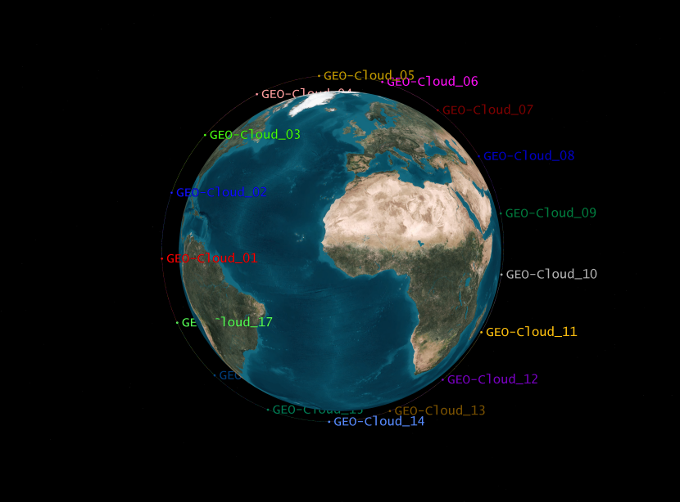

Figure . Constellation of 17 satellites in a SSO orbit at 646km.

### Ground stations design

When the satellite acquires the data, it has to be downloaded to the Ground Stations and then it has to be distributed to the customers. Due to the huge quantity of data and the limitations the download data rate sets, several stations distributed over the surface of the Earth are required. They will allow the satellite to communicate with them and download the images.

The accumulated duration of the accesses to all the ground stations per day is the parameter used to calculate how many stations are included and where they should be located.

The frequency of accesses per day varies with the latitude of the station, being Svalbard at the North Pole the ground station with more accesses per day, one per orbit. In Table 6, the ground stations chosen for the mission, with the number of accesses and duration of the passes by satellite are depicted.

Table Ground stations design, number of accesses per day and duration of the passes.

| Ground Station | Accesses per day | Accumulated duration (h) |
| --- | --- | --- |
| Irkutsk | 7 | 0.95 |
| Puertollano | 4 | 0.62 |
| Svalbard | 15 | 2.21 |
| Troll | 11 | 1.69 |
| Chetumal | 3 | 0.50 |
| Cordoba | 4 | 0.53 |
| Dubai | 4 | 0.57 |
| Kourou | 4 | 0.49 |
| Krugersdorp | 4 | 0.54 |
| Malaysia | 3 | 0.42 |
| Prince Albert | 6 | 0.93 |
| Sidney | 4 | 0.61 |
| TOTAL | 69 | 10.07 |

In Figure 4 the footprints (area in which the satellites can communicate with the ground stations) of the selected ground stations are depicted.

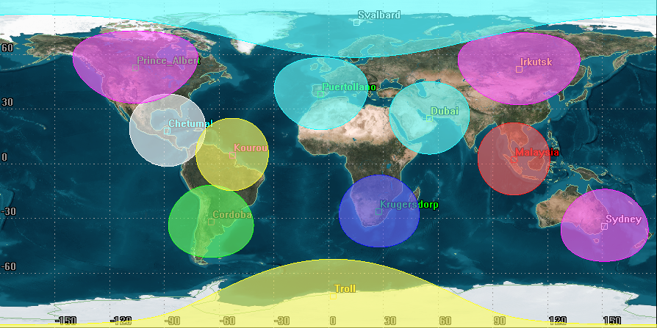

Figure . Footprints of the selected Ground Stations.

## Generated Data Volume

Almost 136M km2/day are daily acquired. With the following expression can estimate the data volume generated:

$$Acquired data volume=\frac{Acquired surface}{{GSD}^{2}}·Nº bands·Digitalization$$

Before downloading the images they are compressed. The ancillary data is included in the process (auxiliary information useful for the geolocation of the images, protocols…). In this case, the ancillary data is estimated to be 12% of the acquired data (based on Deimos 2 satellite measurements), which is added and then compressed. With the values depicted in Table 7 the data on ground can be estimated.

Table . Data handling parameters.

|  |  |
| --- | --- |
| Parameter | Value |
| Daily acquisition | 135 698 500 km2 |
| GSD | 6.7 m |
| Number of bands | 5 |
| Digitalization | 12 bits |
| Ancillary data | 12% |
| Compression rate | 2:1 |
| Download data rate | 160 Mbps |

By including ancillary data before compression, **11.55TBytes** shall be downloaded daily. According to the number of satellites in the system and the download data rate, **each satellite** **will download images during 9.89h/day.** This would provide all the acquired date on ground in a daily basis.

With the selected Ground Stations, the maximum allowed duration of all accesses of a satellite in a day can be calculated: **10.07h/ day** at 160Mbps.

## Summary

To summarize, performances and results of this report are collected in Table 8.

Table . Performances and results.

|  |  |  |
| --- | --- | --- |
|  | Parameter | Value |
| SATELLITE PERFORMANCES | Daily acquisition | 135 698 500 km2 |
| GSD | 6.7 m |
| Swath | 160 km |
| Number of bands | 5 |
| Digitalization | 12 bits |
| Ancillary data | 12% |
| Compression rate | 2:1 |
| Download data rate | 160 Mbps |
|  |  |  |
| CONSTELLATION DESIGN | Number of satellites | 17 satellites |
| Orbit altitude | 646 km |
| Inclination | 97.97 deg |
| LTAN | 10:30 h |
|  |  |  |
| GROUND STATIONS | Number of G/S | 12 |
| Average accesses per day for each satellite | 69 |
| Average duration of all the accesses per day for each satellite | 10.07 h |
|  | **Parameter** | **Value** |
| DATA VOLUME | Total downloaded data per day | 11.55 TBytes |
| Downloaded data per day for each satellite | 695.72 GBytes |
| Time of downloading per day for each satellite | 9.89 h |

# Scenarios definition and users’ model design

In this section technical information about the scenarios and the models of the end users to be tested in the GEO-Cloud experiment are provided.

With the designed scenarios we intend to widely cover several applications that fit the resolution, revisit time, spectral bands… of the designed satellite system.

As seen in Figure 5 and Figure 6, the applications in which satellite imagery is used are related with the spectral bands of the payload, the revisit time and the resolution of the images. In GEO-Cloud, we defined daily revisit time and a multispectral payload with a resolution below 10m.

The applications that can be covered by the GEO-Cloud system are the following: *hydrology, agriculture, environmental monitoring, intelligence, urban development and infrastructures monitoring, mapping, land management (topology, geology, forestry), disaster monitoring and maritime surveillance.*

Other application such as traffic is out of scope because of the very high-resolution requirement (1m). Oceanography is also out of scope because we only consider for GEO-Cloud land surface and not oceans. Meteorology is out of scope because it is covered by geostationary systems, which resolution is between 100 m and 8000 m. However we do consider meteorology based in low Earth orbit satellites for some applications such as precision agriculture or hydrology.

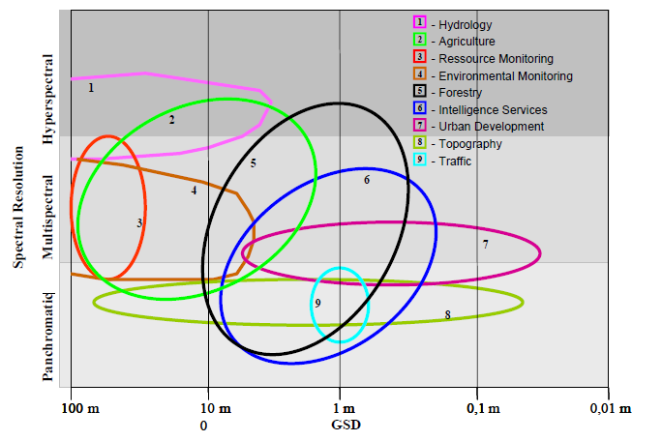

Figure . Earth observation request: GSD versus spectral resolution (From (Sandau)).

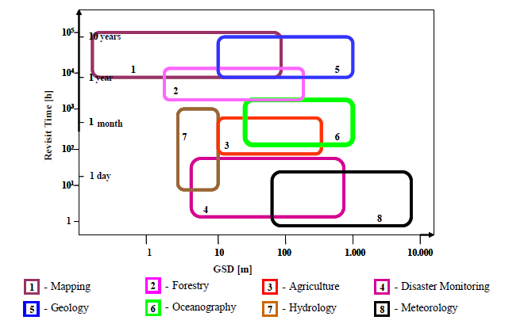

Figure . Earth observation request: GSD vs revisit time (From (Sandau)).

Trying to cover most of these fields, the following scenarios have been designed:

* Scenario 1: Emergencies - Lorca Earthquake (Spain)
* Scenario 2: Infrastructure monitoring - Affection in railway infrastructures by sand movement in desert areas (Spain)
* Scenario 3: Land Management – South West of England.
* Scenario 4: Precision Agriculture – Argentina.
* Scenario 5: Basemaps – Wordlwide.
* Scenario 6: Online Catalogue / Ordering – Worldwide.

End users are also designed and described for each scenario along with the diagram shown in Table 9. In this diagram the service type, processing, storage and communications loads and demand variability are defined.

Table . Relation of the users demand with the service offered.

|  |  |  |  |  |  |  |
| --- | --- | --- | --- | --- | --- | --- |
|  | **Service Type** | | **Loads in Cloud Technology** | | **Demand Variability** |  |
| **COMPANY'S SERVICES** | Basic | Basic | Processing | Low | Constant | **USERS' DEMAND** |
| Medium |
| Advanced | High |
| Storage | Low | Variable |
| High added value | Pull | Medium |
| High |
| Push | Communications | Not urgent/Not RT | Highly variable |
| Urgent/Not RT |
| Hosting | | Urgent/Real Time |

## Scenarios

### Scenario 1: Emergencies - Lorca Earthquake (Spain)

#### Scenario description

In May 11th of 2011, an Earthquake took place in Lorca, in the Region of Murcia (Spain) at 18:47 local time. It was a moderate magnitude 5.1 in moment magnitude scale (M), preceded by a 4.5M foreshock at 17:05 local time. The seismic affected to other regions as Almería, Albacete, Granada, Jaén, Málaga, Alicante, Ciudad Real and Madrid. Several aftershocks occurred up to 3.9M in the following days. See (Instituto Geográfico Nacional) for more information.

Murcia is the most active seismic zone in Spain. Shortly after the second earthquake struck, the Spanish government, at the request of regional government of Murcia, activated the Military Emergencies Unit, a branch of the Spanish Armed Forces responsible for providing disaster relief.

In these kind of natural disasters, emergencies units and humanitarian organizations demand accurate imagery before and after the disaster that has been proven to be very helpful to provide accurate GPS navigation maps to reach affected areas, especially on developing and underdeveloped countries, as demonstrated in the 2010 Haiti earthquake or 2013 Haiyan Typhoon in Philippines (Hot).

#### Response

The Government needs the following service:

* The image of Lorca and surroundings before the first seismic activity is detected.
* The image of Lorca and surroundings when the first seismic activity is detected.
* The image of Lorca and affected regions in the day of the event is requested with urgency.
* After this day:
* All the images daily acquired by the constellation are demanded during the first week, with urgency too, in order to manage emergency services and to assess the damages in the infrastructures.
* Until the first month after the earthquake, weekly images are requested without urgency.
* Then, monthly images also without urgency would be demanded until the first year after the event.

The humanitarian organizations and volunteers may need:

* Images of Lorca before the earthquake, available through WMS and tiles.
* Images of Lorca within the week after the earthquake, available through WMS and tiles.

#### Data distribution

The following data distribution mechanisms will be tested for this use case, as defined in Section 4:

* FTP: Scenes are distributed directly to the government via FTP to be incorporated into the archives and used to their own criteria.
* WMS: To facilitate the analysis of the images to provide an adequate response to the event, a private WMS (Web Map Service) will be provided. From the scenes of the affected region, composites images (mosaic) will be created and populated into the WMS data store. The timestamp of the images will be incorporated to provide support to temporal requests; providing a TIME parameter with a time value in the WMS request does this. Having a WMS enables to have a rational distribution of images among the implicated organizations (firefighters, civil defense, army, etc.). The images can be requested only for needed times and regions by specifying time ranges and geographical area of interest. The WMS can be consumed from the GIS tools used by the emergency response organizations designated by the government.
* Tiles: A public tiles service for the area of interest will be deployed. Humanitarian organizations and volunteers can create accurate maps of the affected area with these data. This service will have potentially high demand (thousands of volunteers accessing the service) in a very short period of time (during the crisis response). Tiles from imagery before and after the disaster will be published.

#### Area of Interest

The Area of Interest (AOI) is the Region of Murcia in Spain (see Figure 7).

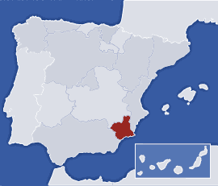

Figure Region of Murcia (Spain) (image from www.20minutos.es ).

#### Users

The main user of the service is the Spanish Government, and other organizations related to emergencies management. Other users could be volunteers and humanitarian organizations.

#### Service Type

The service type is a basic service that can eventually include a hosting service as well for the distribution of data to different emergency services and Estate Forces. Due to the urgency of the images, no added value would be required.

#### Processing Level

The processing level will be low due to the urgent. In this scenario we do not contemplate added value services for damage assessment.

#### Storage Level

The storage level will be low.

#### Communications Level

The communication level is urgent.

#### Demand Variability

The demand is highly variable in this service. See Table 10 for a summary of the service characteristics.

Table . Relation of the users demand with the service offered in the Scenario 1. In orange the characteristics of the service.

|  |  |  |  |  |  |  |
| --- | --- | --- | --- | --- | --- | --- |
|  | **Service Type** | | **Loads in Cloud Technology** | | **Demand Variability** |  |
| **COMPANY'S SERVICES** | Basic | Basic | Processing | Low | Constant | **USERS' DEMAND** |
| Medium |
| Advanced | High |
| Storage | Low | Variable |
| High added value | Pull | Medium |
| High |
| Push | Communications | Not urgent | Highly variable |
| Urgent |
| Hosting | |

### Scenario 2: Infrastructure monitoring. Affection in railway infrastructures by sand movement in desert areas (Spain)

#### Scenario description

New high performance railway lines at ambient conditions characterized by the presence of wind, sand dunes, sand in the air and high temperatures, require innovative developments technology to minimize the impact of these phenomena on different infrastructure elements during the operation.

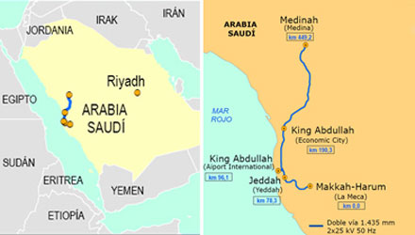

Figure . High Speed line Medina – La Meca in Saudi Arabia. Image from ADIF http://international.adif.es/noticias/espana-construira-y-explotara-la-alta-velocidad-entre-medina-y-la-meca-en-arabia-saudi/12/2011/158

Remote sensing technologies can be applied to assess the risk of affection in the infrastructure and to minimize and prevent the impact: Sand movement and speed, risk maps, sand storms monitoring, floods monitoring, etc.

Satellite imagery can be combined with unmanned aerial vehicles (UAV), with higher resolution and flexible operation modes, to provide data to assist in the deployment, operation and maintenance of these lines.

#### Response

The solicited service is based on the following premises:

* Coverage during operation of the infrastructure.
* Use of archive images to provide information about dunes movements and speed.
* Monthly revisit time.
* Urgent images only in case of storms and floods to inspect damages in the infrastructures.
* The images require an analysis to identify risks zones, dune and sand speed fields, etc.

#### Data distribution

* WMS: A Web Map Service will be deployed to distribute the scenes of the area of interest to the managers of the infrastructure. Imagery and derived products (risk maps, wind speed fields, etc.).
* Value added services (WFS, HTTP/REST, Tiles, etc.). Interactive value-added services may be provided to the managers in order to have monitoring tools.

#### Area of Interest

Several areas of interest have been detected: The Medina – La Meca (Saudi Arabia) railway line currently in construction and the south of Spain (Andalucía) where testing technologies with sensors and UAV are in development.

#### Users

* Private organizations, responsible of the construction and operation of the lines.
* Public institutions responsible of the management of the railway infrastructures.

#### Service Type

The service type is advanced. It includes mosaics of the area of interest and combination with other sources of information.

#### Processing Level

The processing level is high

#### Storage Level

The storage level is high.

#### Communications Level

The communication level is not urgent.

#### Demand Variability

The demand is variable. See Table 11 for a summary of the service characteristics.

Table . Relation of the users demand with the service offered in the Scenario 2. In orange the characteristics of the service.

|  |  |  |  |  |  |  |
| --- | --- | --- | --- | --- | --- | --- |
|  | **Service Type** | | **Loads in Cloud Technology** | | **Demand Variability** |  |
| **COMPANY'S SERVICES** | Basic | Basic | Processing | Low | Constant | **USERS' DEMAND** |
| Medium |
| Advanced | High |
| Storage | Low | Variable |
| High added value | Pull | Medium |
| High |
| Push | Communications | Not urgent | Highly variable |
| Urgent |
| Hosting | |

### Scenario 3: Land Management – South West of England

#### Scenario description

There is a need to characterize landscape and crops in the South West of England, United Kingdom. Besides, the users demand a multitemporal product which allows analysing the land cover dynamics and detecting changes. For this task, multitemporal classification and regression techniques are used to provide products exploiting the high revisit time, high spatial resolution, high swath and large number of bands in the system (Sensyf).

#### Response

The primary focus of the service is Landscape Management linked to the use of the land for agricultural purposes versus conservation.

The service is the following:

* Satellite images with a weekly frequency shall be offered, including the requested processing through a push type service.
* Multitemporal Land Cover Classification and Change Detection Service are needed. Land cover and land cover change products will be generated from mosaics with the same temporal frequency, weekly, and service type, push.

#### Data distribution

* WFS to provide direct access to the derived products: Land cover, etc.
* Value-added services (REST/HTTP, WMS, Tiles) for the creation of web applications and interactive solutions.

#### Area of Interest

The Area of Interest is the South West of England, United Kingdom, see Figure 9.

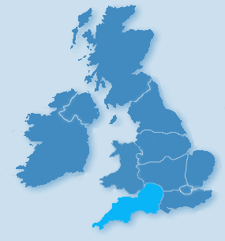

Figure . South West of England (image from http://www.holiday-home-dealers.co.uk/)

#### Users

The user of this service is the European Landscape Convention.

#### Service Type

The service type is high added value (Push). Processing is required to offer the requested services: crops characterization, classification, irrigation planning, and change detection.

#### Processing Level

The processing level is medium.

#### Storage Level

The storage level is medium.

#### Communications Level

The communication level is not urgent since the changes in the crops are not immediate and the frequency of the images acquisition is higher than such changes.

#### Demand Variability

The demand is variable. It depends on the season. See Table 12 for a summary of the service characteristics.

Table . Relation of the users demand with the service offered in the Scenario 3. In orange the characteristics of the service.

|  |  |  |  |  |  |  |
| --- | --- | --- | --- | --- | --- | --- |
|  | **Service Type** | | **Loads in Cloud Technology** | | **Demand Variability** |  |
| **COMPANY'S SERVICES** | Basic | Basic | Processing | Low | Constant | **USERS' DEMAND** |
| Medium |
| Advanced | High |
| Storage | Low | Variable |
| High added value | Pull | Medium |
| High |
| Push | Communications | Not urgent | Highly variable |
| Urgent |
| Hosting | |

### Scenario 4: Precision Agriculture - Argentina

#### Scenario description

Small farm operators, cooperatives, large agro-holdings, agricultural land investment trusts, logistics and supply chain operators need homogeneous and reliable means to manage their crops. Precision Agriculture provides support services for irrigation, based on the use of Earth Observation (EO) data, hydrological models and meteorological data. Using high resolution imagery, inadequate irrigation or practices can be identified quickly and other agricultural treatments can be more accurately assessed and optimized.

In Latin America the leading country is Argentina, where it was introduced in the middle 1990s with the support of the National Agricultural Technology Institute (Sensyf), (Astrium).

#### Response

The designed constellation will provide mosaics of Argentina in a daily basis, which shall be processed in order to offer several layers of precise information at the resolution of the satellite system to the users.

Some processing shall offer info about irrigation planning, improved management of fertilizer usage, meteorological data affecting crops and fruit maturity.

#### Data distribution

* WFS to provide direct access to the derived products.
* Value-added services (REST/HTTP, WMS, Tiles) for the creation of web applications and interactive solutions.

#### Area of Interest

The Area of Interest is Argentina, see Figure 10.

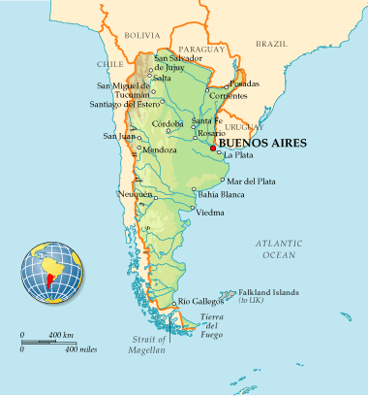

Figure . Map of Argentina (from <http://www.dk.co.uk/static/cs/uk/11/worldfactfile/countries/ar.html>).

#### Users

The user is the National Agricultural Technology Institute.

#### Service Type

The service type is high added value (push/hosting) (subscription services for agriculture treatments, irrigation planning and general monitoring… Hosting could be employed for users that do not have where storage the data).

#### Processing Level

The processing level is high (several layers of post processing shall be offered to the users employing mosaics of the country, i.e. the National Agricultural Technology Institute).

#### Storage Level

The storage level is high.

#### Communications Level

The communication level is not urgent.

#### Demand Variability

The demand variability is constant (depending on the season). See Table 13 for a summary of the service characteristics.

Table . Relation of the users demand with the service offered in the Scenario 4. In orange the characteristics of the service.

|  |  |  |  |  |  |  |
| --- | --- | --- | --- | --- | --- | --- |
|  | **Service Type** | | **Loads in Cloud Technology** | | **Demand Variability** |  |
| **COMPANY'S SERVICES** | Basic | Basic | Processing | Low | Constant | **USERS' DEMAND** |
| Medium |
| Advanced | High |
| Storage | Low | Variable |
| High added value | Pull | Medium |
| High |
| Push | Communications | Not urgent | Highly variable |
| Urgent |
| Hosting | |

### Scenario 5: Basemaps – Worldwide

#### Scenario description

Satellite operators, space agencies and mapping companies offer basemaps as part of their services and data product. Built from the satellite scenes, they provide seamless and cloud-free coverage of certain region surface (countries, continents and worldwide) with multiple zoom layers and high detail. They are distributed as data archives (FTP, direct download) or through OGC Web Services (WMS) and Tiles. These are some examples:

* NASA’s Blue Marble: offers a year’s worth of monthly composites at a spatial resolution of 500 meters. These monthly images reveal seasonal changes to the land surface: the green-up and dying-back of vegetation in temperate regions such as North America and Europe, dry and wet seasons in the tropics and advancing and retreating Northern Hemisphere snow cover. They are available for download as georreferenced raster files.

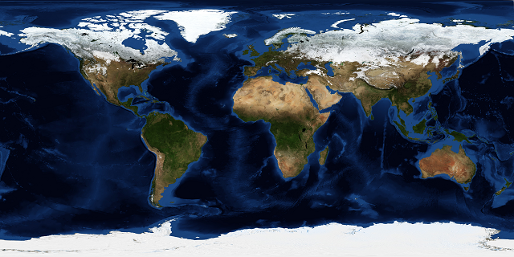

Figure . NASA’s Blue Marble from December with topography and bathymetry.

* SPOTMaps: From Astrium, provides 2.5m, natural color, seamless ortho-mosaics derived from SPOT 5 data, providing nationwide and regional basemaps for a large part of the globe. They are currently available over more than 110 countries, and more than 94 million km². The coverage is growing and updated on a monthly basis.

#### Response

With the global daily coverage of the GEO-Cloud constellation of satellites, a monthly true-color basemap can be built with very high detail and coverage percentage (cloud-free). In tropical lowlands, cloud cover during the rainy season can be so extensive that obtaining a cloud-free view of every pixel of the area for a given month may not be possible.

Processing will consist of creating monthly mosaics from the daily coverage of the constellation, removing clouds and applying color adjustments to create true-color and visually attractive aerial basemaps.

Resolution of the basemaps will depend on the storage and processing capacity, it will be studied further during the implementation of the scenario.

#### Data distribution

Data will be delivered though cached WMS and tiles.

#### Area of Interest

The area of interest is the whole world. Country or continent coverages can be represented. We will focus on Europe.

#### Users

* Governmental clients.
* Infrastructure managers.
* Third-party service providers.

#### Service Type

The service type is high added value (push/hosting), using on-line delivery mechanisms.

#### Processing Level

The processing level is high (creation of a monthly mosaic from a catalogue of daily images, cloud removal, color adjustments…)

#### Storage Level

The storage level is very high. It can be modulated with the maximum zoom level / resolution offered and the area of interest.

#### Communications Level

The communication level is not urgent.

#### Demand Variability

The demand variability is variable. See Table 14 for a summary of the service characteristics.

Table . Relation of the users demand with the service offered in the Scenario 5. In orange the characteristics of the service.

|  |  |  |  |  |  |  |
| --- | --- | --- | --- | --- | --- | --- |
|  | **Service Type** | | **Loads in Cloud Technology** | | **Demand Variability** |  |
| **COMPANY'S SERVICES** | Basic | Basic | Processing | Low | Constant | **USERS' DEMAND** |
| Medium |
| Advanced | High |
| Storage | Low | Variable |
| High added value | Pull | Medium |
| High |
| Push | Communications | Not Urgent | Highly variable |
| Urgent |
| Hosting | |

### Scenario 6: Online Catalogue / Ordering – Worldwide.

#### Scenario description

Having an online browsing, querying and ordering tool for satellites missions is one of the main elements to request images from the historic archive.

This kind of tools gives access to the mission archive, discovery tool gives customers:

* Access to the mission images archives via the Internet
* An instant preview of browse images over an area.
* Searching on metadata.
* Ability to upload KML, KMZ or shapefiles to refine your area of interest

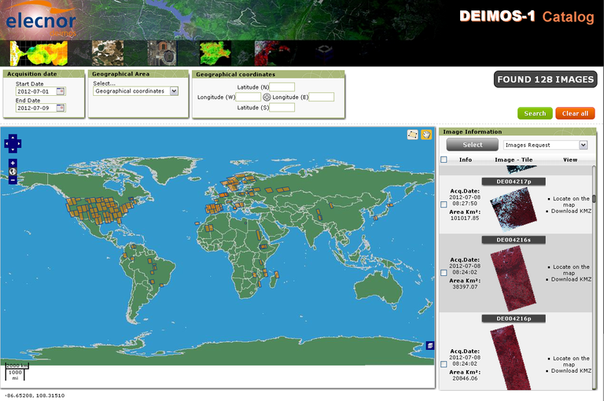

Figure . DEIMOS-1 Online Catalogue.

#### Response

In this scenario, an online catalogue for the constellation of satellites proposed will be tested, taking into consideration the loads of users, queries to the catalogue (using CSW standard) and rendering times for the features (footprints, previews, etc).

#### Data distribution

This is a value added service, using CSW to query the catalogue and HTTP/REST for rendering the previews and footprints.

#### Area of Interest

Worldwide.

#### Users

Potential customers/users of the satellite constellation images.

#### Service Type

Value-added services.

#### Processing Level

The processing level is low. Metadata associated with the images is the main element of processing in this scenario.

#### Storage Level

The storage level is high, the images metadata and previews should be stored.

#### Communications Level

The communication level is not urgent.

#### Demand Variability

The demand variability is variable. See Table 15. Relation of the users demand with the service offered in the Scenario 6. In orange the characteristics of the service for a summary of the service characteristics.

Table . Relation of the users demand with the service offered in the Scenario 6. In orange the characteristics of the service.

|  |  |  |  |  |  |  |
| --- | --- | --- | --- | --- | --- | --- |
|  | **Service Type** | | **Loads in Cloud Technology** | | **Demand Variability** |  |
| **COMPANY'S SERVICES** | Basic | Basic | Processing | Low | Constant | **USERS' DEMAND** |
| Medium |
| Advanced | High |
| Storage | Low | Variable |
| High added value | Pull | Medium |
| High |
| Push | Communications | Not urgent | Highly variable |
| Urgent |
| Hosting | |

## Summary

In this section 6 scenarios has been designed to be tested in the GEO-Cloud experiment. In addition, the models that will be used to emulate the end users accessing the BonFIRE cloud have been designed. From these scenarios and end users models requirements to compute the processing, storing and distribution of data will be extracted.

Other additional scenarios that might be tested are defined (See Section 9).

# Imagery distribution and visualization system design

## Concepts and evolution of imagery distribution and visualization

The demand and the requirements for Earth Observation (EO) data distribution and value-added services have evolved drastically over the last years. The amount and the volume of requested data have increased exponentially, in line with the processing and analyzing capabilities and the number of EO missions, both private and public, in orbit. In addition, the variety and the diversity of data requests have increase to a level where most of the users request and use data from more than one satellite or satellite operator.

This, in turn, increases the challenge for EO satellite operators, Space Agencies and EO Data providers to process the data and to offer the access to the different data as coherently and easily as possible.

EO is a key instrument to the governments (from local to national level) for the management of critical elements under its umbrella: Natural resources, climate, economic activities, boundaries control, etc. Thus, the way this EO information is distributed and managed through available technologies is focused on interoperability and the maximization of the investment by reusing the infrastructures.

On the other hand, there is an increasing demand of EO data and services from new sectors and user typologies, some of which are newcomers to the EO products. These new users, which are in some cases are non-experts, are demanding more flexible and instant access to EO products and services. Besides of requiring high volume of data, they also demand fast and easy access to the data. The benefit from this approach is to reach an increasing number of users and vertical markets.

Both approaches should be considered in an EO distribution and visualization layer, to cover the requirements both from governmental users, mostly through Spatial Data Infrastructures (SDI) and interoperability standards (OGC) but also the general public and companies outside from the traditional EO workflows.

In the following report, we review the current state of the art for satellite imagery distribution, visualization and on-line services creation.

We provide hypothesis on the benefits on using cloud and virtual infrastructures for EO imagery distribution and the creation of demand-driven value-added services.

Finally, we propose a high-level architecture for on-line imagery distribution and services creation to be tested in the Fed4Fire services.

### Interoperable Earth Observation imagery delivery: Spatial Data Infrastructures

The term spatial data infrastructure was coined in 1993 by the U.S. National Research Council to denote a framework of technologies, policies, and institutional arrangements that together facilitate the creation, exchange, and use of geospatial data and related information resources across an information-sharing community. Such a framework can be implemented narrowly to enable the sharing of geospatial information within an organization or more broadly for use at a national, regional, or global level. In all cases, an SDI will provide an institutionally sanctioned, automated means for posting, discovering, evaluating, and exchanging geospatial information by participating information producers and users. SDI extends a GIS by ensuring geospatial data and standards are used to create authoritative datasets and policies that support it.

Many government administrations have recognized this critical problem and have initiated coordinated actions to facilitate the discovery and sharing of spatial data, creating the institutional basis for Spatial Data Infrastructures (SDI). These efforts were firstly driven in the 90’s by the U.S with the creation of the Federal Geographic Data Committee (FGDC). A few years later, Europe joined these approach by creating  the European Umbrella Organization for Geographic Information (EUROGI) and more recently, the Infrastructure for Spatial Information in Europe (INSPIRE) initiative for the creation of a European Spatial Data Infrastructure (ESDI). An increasing number of countries and regions around the world have joined the implementation of their own SDIs as a strategic need for their economic and social development.

SDIs are driven by several standards and initiatives

* The Open Geospatial Consortium (OGC) Standards.
* The ISO/TC 211 on ISO/TC 211 Geographic information/Geomatics, responsible for the ISO geographic information series of standards.
* At European level, INSPIRE and GMES/Copernicus.

EO products are relevant for an SDI, since many of the information managed by these infrastructures come from satellite observations, and many organizations expect the EO products, even from private missions, to be delivered through interoperable and standard mechanisms. Some of the standards managed proposed by OGC and ISO are of specific application to EO data services and data, mainly, in the case of OGC standards:

* WMS and WMTS: For Web Maps services on Internet.
* WCS: For accessing coverages data (i.e. raster files from EO satellites) on Internet.
* WFS: For accessing features data from vector data sources on Internet.
* CSW: Catalog services on Internet.
* HMA: HMA provides harmonized and standardized access to ESA mission data and to other mission ground segments, based on OGC standards.

### Demand-driven Earth Observation images delivery

Our modern society is full of spatial problems that become more and more complex. In order to solve these complex problems, there is a high demand to high-quality information, excellent information models, services and software tools, etc. However, the current Spatial Data Infrastructures (SDIs) are not able to meet fully these demands (since their developments were more supply driven). SDIs are built to facilitate the access to data and services. So far, little attention is given to the actual and desired use of SDIs for solving spatial problems during the first stages of building SDIs. Most effort is currently spent to defining data, metadata, standards, and technology. In other words, the development of the current SDIs is not based on the needs of the actual, desired and/or potential users.

The complexity of the technologies around the SDIs has caused other players and technologies to take the place of the SDIs for providing effective geospatial and EO end-user services. Big companies linked to the Internet revolution like Google or small specialized companies like MapBox have redefined, with their own and existing Internet technologies, the way that geospatial information and services are available via the Internet. Thus, they have driven the universalized the access to remote sensing and geospatial information beyond standardization initiatives promoted by the SDIs.

The technologies on top of which these services have been successfully built are inherited and inspired by the Internet world rather than the traditional GIS industry.

* Cloud and HPC infrastructures to reduce the processing times of imagery from the satellite and ground stations to an end-user friendly product.
* Traditional spatial RDBMS like PostgresSQL and PostGIS, but also NoSQL databases for handling metadata and other suitable information.
* Effective delivery mechanisms like CDNs and distributed caches, mainly based on image tiles.
* Internet-friendly data interchange formats: Tiles and aggregation of tiles (MBTiles) for maps and binary imagery and GeoJSON, TopoJSON and UTFGrid for features and vectorial information.
* REST Web Services instead of SOA based, heavy XML interfaces.
* Client-side processing, leveraging the power of GPUs and user computers for rendering and analysis: Vector tiles, Canvas, Raster analysis.
* Design-driven HTML/JavaScript and Mobile User Interfaces highly focused on the User Experience.

This is how traditional SDI technologies are mapped with these new technologies.

|  |  |
| --- | --- |
| **SDI technology** | **Demand-driven Geospatial technologies** |
| RDBMS and Geoespatial Extensions, Metadata Catalogs. | RDBMS + NoSQL DB + Geospatial extensions, Metadata Catalogs. |
| Geospatial Application servers (Map servers, features servers | Tile servers. Rest Web Services. |
| WMS, WMST, Cached Tiles. | Cached Tiles, MBTiles, CDNs. |
| WFS | REST WS/GeoJSON, REST WS/TopoJSON |
| WPS | Cloud processing, REST WS |
| WCS | REST WS |

## Geo-Cloud Image Distribution and Visualization System (Geo-Cloud IDV) design

From the geospatial technologies and standards reviewed in Section 4.1, a selection is made to fulfill several requirements specific to Earth Observation imagery and use cases and better suite in a distributed infrastructure provided by the Fed4Fire testbeds.

For interoperability purposes, most distribution mechanisms will be standards-based (OGC). Some standards, like CSW, are not taken into consideration since they are not intended for a massive use in the EO imagery generation workflow.

HMA is not yet currently taken into consideration since it is still and work in progress standard. More user-focused approaches will be adopted for value-added products and services, and fast visualization.

For the experiments designed, the focus will be on WMS and Tiles distribution mechanisms.

### Distribution and Visualization mechanisms for Geo-Cloud IDV

#### FTP

This will be the mechanism to distribute the raw data from the ground stations to the distribution infrastructure. Moreover, raw data can be delivered to the end user by this simple mechanisms using simple access protocol (user/password, SFTP accounts, etc.). This is the more common way to distribute the images and products in the industry nowadays.

#### WMS

A Web Map Service (WMS) enables the visualization of EO data on the World Wide Web. This standard does not provide the actual raw data; instead it just provides a georeferenced image (e.g. PNG, JPEG or GIF files) of the data that can be queried by bounding box, reprojected, styled, etc. It enables the integration into GIS clients and spatial data infrastructures.

In the case of large and high resolution EO imagery, the following workflow is needed in order to provide efficient delivery through WMS:

1. Image Mosaics. Preparation of Image Mosaics from separate georeferenced images from the satellites for an area of interest, assembling a set of overlapping geospatially rectified images into a continuous image. Additionally to preparing the mosaic, it is convenient the creation of “overviews” within the file, which is basically a downsampled version of the raster data suitable for use at lower resolutions.

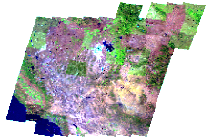

Figure . Mosaic of images from different satellite scenes.

1. Image Pyramids. For very large images, it is convenient to build Image Pyramids. An image pyramid builds multiple mosaics of images, each one at a different zoom level, making it so that each tile is stored in a separate file. This comes with a composition overhead to bring back the tiles into a single image, but can speed up image handling through WMS as each overview is tiled, and thus a sub-set of it can be accessed efficiently (as opposed to a single GeoTIFF, where the base level can be tiled, but the overviews never are).

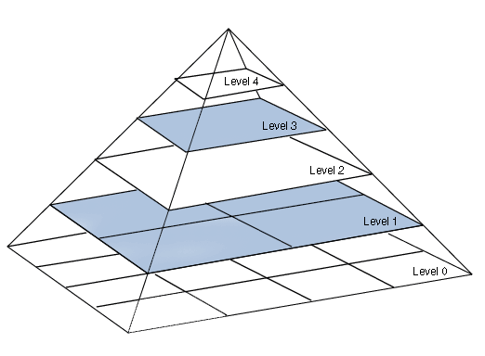

Figure . Building Image Pyramids.

Once the mosaics and pyramids are created from the original data sources, delivery through WMS is more efficient.

The number of pyramids needed depend on the pixels size of the image and the tile size, and it is given by the following formula:

Equation . Number of pyramids.

$$n=\frac{\log{(p_{i})}}{\log\left(2\right)}-\frac{\log\left(p_{t}\right)}{log⁡(2)}$$

where $n$ is the number of pyramids, $p_{i}$ is the image size in pixels, and $p_{t}$ is the tile size in pixels.

For example, for a square area of 1.675 km² (Lorca extension, a village in Spain, see Section 3), an image mosaic built from satellite scenes with a resolution of 6.7 m/pixel (see Section 1) will have a size of 250.000 x 250.000 pixels. From Equation 1 and for a tile size of 512 x 512 pixels, this gives 8 for the number of pyramids needed.

#### WFS

Web Feature Service (WFS) defines a standard for exchanging vector data over the Internet. With compliant WFS, clients can query both the data structure and the source data. Advanced WFS operations also support feature locking and edit operations.

#### WCS

The Web Coverage Service (WCS) supports the networked interchange of geospatial data as "coverages" containing values or properties of geographic locations The specification details interfaces that allow client applications to seamlessly query and access raw or processed satellite imagery, digital elevation models, raster data, and other types of coverage data stored on one or more distributed servers.

Unlike the Web Map Service (WMS) which filters and portrays spatial data as static geo-registered "pictures", the Web Coverage Service provides allows a client application to query and access geospatial information that represents a fully tessellated surface (satellite data, digital orthophotos, and so forth). The returned data can be used for client-side rendering, multi-valued coverage analysis, and input into scientific models and other client applications beyond simple viewers.

#### Web Maps, Tiles and Tiles Caches

Tiles are the fastest mechanism to visualize EO imagery on the Internet. They are not intended for direct distribution, and are pre-rendered with certain quality, zoom levels and projections.

A continuous image of the world at street level detail, the kind of resolution managed offered by the constellation proposed, would be millions of pixels wide – much too large to download or hold in memory at once using WMS protocols.

In practice, when creating maps for the Web, they are made up of many small, square images called tiles which are typically 256 x 256 pixels and are placed side-by-side in order to create the illusion of a very large seamless image.

The way to get more detail in maps is by using zoom levels. Higher zoom levels increase the physical size of the displayed map but also increase the amount of detail shown.

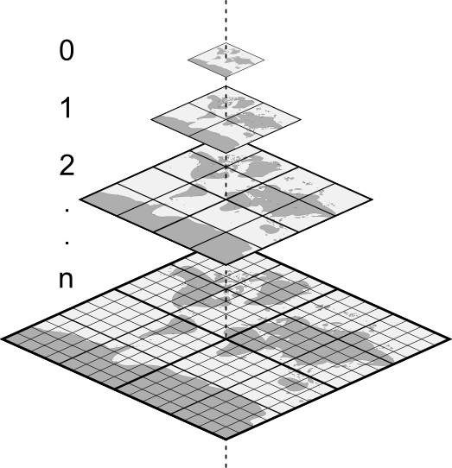

Figure . Mercator tile pyramid. Each tile is 256 x 256 pixels.

Google Maps, Microsoft Virtual Earth, Yahoo Maps, and other commercial API providers as well as OpenStreetMap are using the same projection and tiling profile and tiles are therefore compatible. The extents of all tiles as well as the zoom levels (resolution in meters per pixel) are predefined for the whole Earth. The difference is only in the way how the equivalent tiles are indexed. There are three main systems of tile addressing: Google XYZ, Microsoft QuadTree and other OGC or OSGeo standards or recommendations like TMS, WMTS and WMS-C.

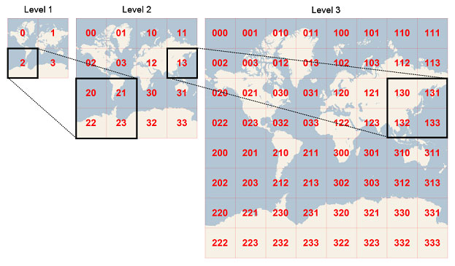

Figure . Bing Maps tiles scheme.

To display the tiles, projection has to be also taken into consideration. For Web Maps based on tiles, Spherical Mercator EPSG:900913 (EPSG:3857) and WGS84 Datum are commonly used.

When using this projection, the resolution and scale for zoom level at equator (scales will fluctuate with latitude) can be calculated with the following formula:

Equation . Resolution per zoom level.

$$resolution= 156543.04\frac{m}{pixel}\frac{\cos\left(lat\right)}{2^{z}}$$

The number of tiles for squared projections is $n_{z}=4n_{z-1}$, where $n$ is the number of tiles and $z$ the zoom level.

For an average tile size of 20 KB, this gives the following estimation of resolutions, number of tiles and size on disk per zoom level.

Table . Resolution, tiles and size per zoom level.

|  |  |  |  |
| --- | --- | --- | --- |
| Zoom level | Resolution (m/pixel) | Number of Tiles | Size on disk (MB) |
| 1 | 78271.52 | 4 | 0 |
| 2 | 39135.76 | 16 | 0 |
| 3 | 19567.88 | 64 | 0 |
| 4 | 9783.94 | 256 | 0 |
| 5 | 4891.97 | 1,024 | 0 |
| 6 | 2445.98 | 4,096 | 0 |
| 7 | 1222.99 | 16,384 | 0 |
| 8 | 611.50 | 65,536 | 1 |
| 9 | 305.75 | 262,144 | 5 |
| 10 | 152.87 | 1,048,576 | 20 |
| 11 | 76.44 | 4,194,304 | 80 |
| 12 | 38.22 | 16,777,216 | 320 |
| 13 | 19.11 | 67,108,864 | 1,280 |
| 14 | 9.55 | 268,435,456 | 5,120 |
| 15 | 4.78 | 1,073,741,824 | 20,480 |
| 16 | 2.39 | 4,294,967,296 | 81,920 |
| 17 | 1.19 | 17,179,869,184 | 327,680 |
| 18 | 0.60 | 68,719,476,736 | 1,310,720 |
| 19 | 0.30 | 274,877,906,944 | 5,242,880 |

##### Tiles caches

Web Maps are often static. As most mapping clients render WMS (Web Map Service) data every time they are queried, this can result in unnecessary processing and increased wait times. Tile Caches optimizes this process by saving (caching) map images, or tiles, as they are requested, in effect acting as a proxy between client and any WMS server.

As new maps and tiles are requested, the tiles caches intercepts these calls and returns pre-rendered tiles if stored, or calls the server to render new tiles as necessary. Thus, once tiles are stored, the speed of map rendering increases by many times, creating a much improved user experience.

A tiling strategy controls when your tiles are created and for what areas (geographic extents) they are created. Tile sets can be created proactively (by “seeding”), or on-demand.

**Seeding:** Seeding creates tiles prior to requests from clients, so that they will already be available when the first users start navigating the map. Because the images exist on the server, there is never any wait time for the tile to be rendered, and is sent immediately to the client.

While seeding is very responsive to the end-user, there are some disadvantages to the administrator:

* Planning the tile strategy takes time.
* Creating the tiles takes computing power (typically days for processing zoom levels > 12 and the time to seed grows exponentially).
* Storing the tiles takes disk space.

**On-Demand caching**: Caching tiles “on-demand” mean that the first user/client to navigate to an uncached area will wait while the corresponding tiles are drawn by the server, and then delivered to the client. Once rendered, the tiles are added to the service’s cache folder and remain on the server until updated or deleted by the expiration policy or cache administrator. Subsequent visitors to that same area will not have to wait for the tiles to be rendered, because they’ll already exist.

The main advantage to on-demand caching is that it requires no preprocessing, and because only the data requested will be cached it can potentially save disk space. The disadvantage of on-demand caching is that because viewing will be slower and then intermittently accelerated it can affect the quality of the user experience.

In practice, a compromise between both strategies has to be accomplished depending on the use case.

#### CDN and distributed caching

To speed-up the tiles distribution to the end-users, CDNs and distributed caching can be used. At the end, tiles are just static files that can be deployed in several nodes in a CDN and served to the client, optimizing the performance, by selection of node locations that are best for serving content to the user. This may be measured by choosing locations that are the fewest hops, the least number of network seconds away from the requesting client, or the highest availability in terms of server performance (both current and historical). Examples of CDNs are Akamai or Amazon CloudFront.



Figure . CDN architecture.

#### Value-added products and services

Value added products and services typically involve the processing of the satellite scenes and its bands to produce post-processed products with additional value beyond the raw data.

These value-added products cover different markets and use cases, as described in Section 3: hydrology, agriculture, environmental monitoring, intelligence, urban development and infrastructures monitoring, mapping, land management (topology, geology, forestry), disaster monitoring and maritime surveillance, etc.

|  |
| --- |
| Riego cultivosControl de Superficies RegadasNivosidad cuencaZonas inundables |

Figure . Remote Sensing value-added products.

Moreover, there is an increasing demand for on-line services based on those products. These services can be delivered though vertical solutions and businesses though Internet (web portals and applications) or by providing APIs and controlled and programmatic access to these data (APIs and Web Services).

#### Summary

Depending on the use case and scenario, a distribution and visualization mechanism should be chosen. In the following table, we present a summary of the different alternatives evaluated.

|  |  |  |  |
| --- | --- | --- | --- |
|  | Pros | Cons | When to use |
| FTP | Simple and direct mechanism | Only for distribution. Not selection, query, etc. | Access to RAW data. |
| WMS/WFS/WCS | Standards based | Low performance, hard to understand for non-experts. | When the user needs access to raw or processed data and features for certain areas and custom projections, bounding boxes, etc.  Low users demand. |
| Cached Tiles (WMTS…) | Fast. Standards-based. | Pre-rendered. Fixed projections. | Massive user services, value added services. |
| REST/HTTP | Fast, easy to integrate | Non-standard (although some OGC services have been extended to REST interfaces) | Massive user services, value added services. |
| CDN | Fast delivery | Hard to configure and deploy.  Non standard. |  |

### Geo-Cloud IDV Architecture

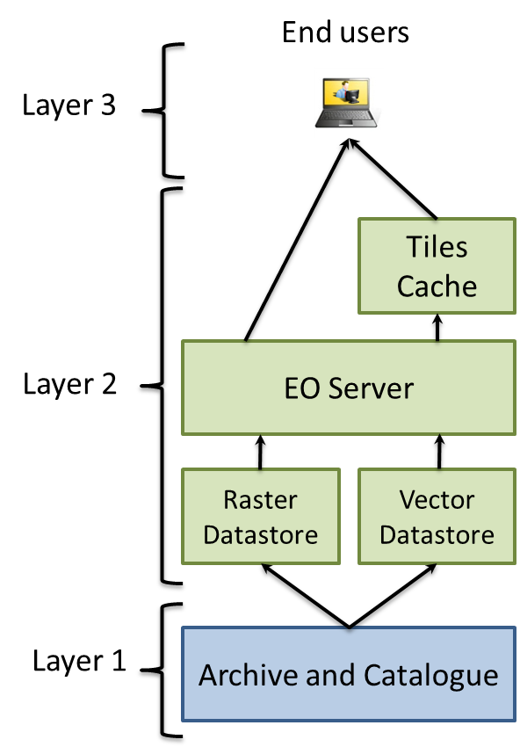

Figure . Components architecture for data distribution and visualization.

#### Components

##### Archive and Catalogue

The processed images will be stored and catalogued for their distribution in both ways direct downloading (low added value services) and web based service (high added value services), as described in Section 5.

##### Datastore

The datastore will be fed from the archive and catalogue with the required scenes from the archive to cover the uses cases specified in TEC-02. In some cases, additional processing will be needed to optimize these scenes for distribution through OGC Web Services, to populate the tiles cache, etc.

|  |  |  |  |
| --- | --- | --- | --- |
| **Instance type** | **CPU cores** | **Memory** | **Features** |
| storage | - | 300 GB |  |

The datastore will be based on two components:

* A geospatial database, to handle geometries and vector features, and in some cases, raster files. It will be based on PostGIS database.
* The instance filesystem.

##### EO Server

A map and feature server for sharing, analyzing, and editing geospatial data from spatial data sources using open standards. It implements OGC Web Services (WMS, WFS, WCS, etc.) as well as providing tiling and cache mechanisms.

For most of its web services, it can be scaled horizontally by adding several EO Server nodes to the infrastructure.

|  |  |  |  |
| --- | --- | --- | --- |
| **Instance type** | **CPU cores** | **Memory** | **Features** |
| xlarge+ | 4 | 8GB | Higher CPU clock speed (over 3GHz) |

|  |  |  |  |
| --- | --- | --- | --- |
| **Instance type** | **CPU cores** | **Memory** | **Features** |
| Load balancer | - | - | EaaS |

It will be based on the Open Source SW GeoServer.

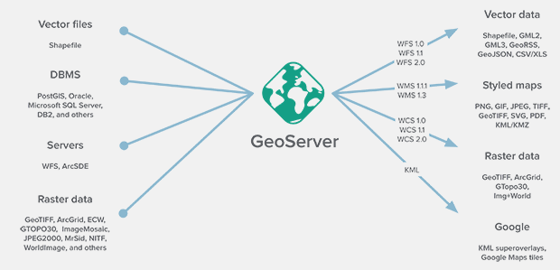

Figure . Geoserver features.

##### Tiles Caches

For the tiles cache, GeoWebCache will be used. It is s a Java web application used to cache map tiles coming from a variety of sources such as OGC Web Map Service (WMS). It implements various service interfaces (such as WMS-C, WMTS, TMS, Google Maps KML, Virtual Earth) in order to accelerate and optimize map image delivery. It can also recombine tiles to work with regular WMS clients.

GeoWebCache can scale horizontally by adding nodes sharing the same cache data store. To store the cached tiles, high storage capacity is needed.

|  |  |  |  |
| --- | --- | --- | --- |
| **Instance type** | **CPU cores** | **Memory** | **Features** |
| storage | - | 500 GB |  |

|  |  |  |  |
| --- | --- | --- | --- |
| **Instance type** | **CPU cores** | **Memory** | **Features** |
| Custom | 4 | 2GB | Higher CPU clock speed (over 3GHz) |

|  |  |  |  |
| --- | --- | --- | --- |
| **Instance type** | **CPU cores** | **Memory** | **Features** |
| Load balancer | - | - | EaaS |

#### Distributed architecture

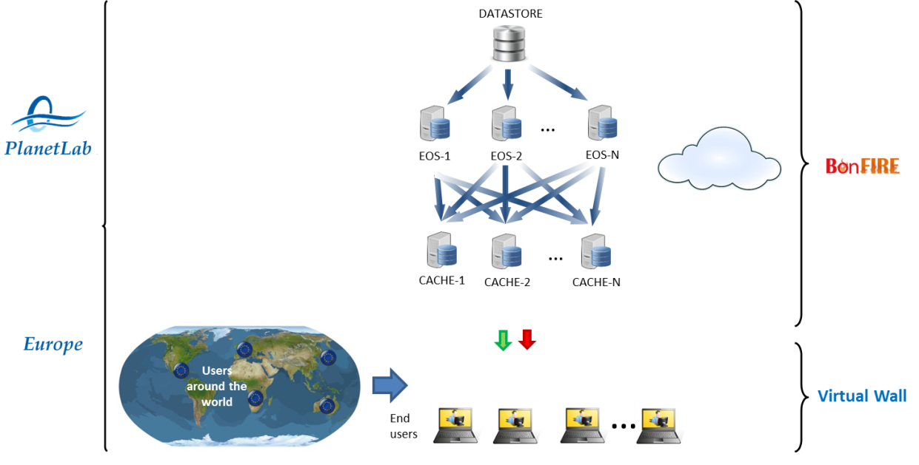

Figure . Geo-Cloud IDV in Fed4Fire.

Since some of the components of the GEO-Cloud IDV may scale horizontally, the EaaS feature of BonFire will be used.

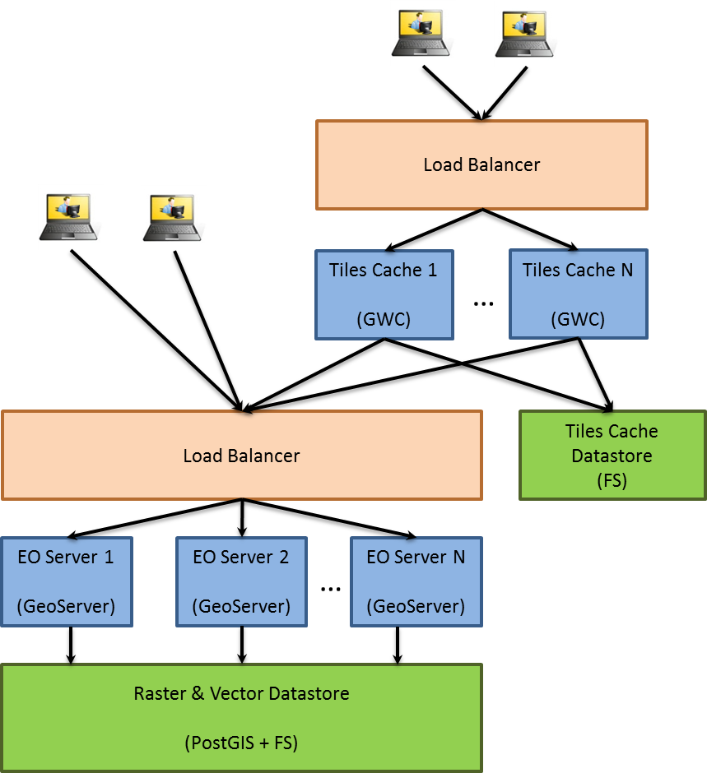

Figure . GEO-Cloud IDV Instances.

## Summary

We have proposed an initial architecture for the Imagery Distribution and Visualization System for the GEO-Cloud experiment (GEO-Cloud IDV). From a selection of distribution and visualization mechanisms, we have selected the ones that better fit in the use cases and satellite system designed. Making use of the BonFire facilities, the objective is to push the system to the limits to test massive EO data distribution and service delivery using cloud infrastructures.

# Data processing and storage in BonFIRE

In this document the data processing chain in to be implemented in the BonFIRE cloud is presented. This chain begins after the reception of the images in the ground stations, which are emulated in Virtual Wall. Thus, direct connection between Virtual Wall and BonFIRE is required.

The whole product processing chain is intended to be implemented in cloud. For that purpose an orchestrator that manages the processing stages of the data and the cloud has to be ad hoc implemented during the implementation stage of the experiment.

For the data delivery and distribution, Web Services (based on OGC standards and state-of-the-art Web technologies) will be used.

In addition, the data distribution modules will be connected to Virtual Wall, where VMs with different processing loads emulating end users accessing the GEO-Cloud services will be implemented.

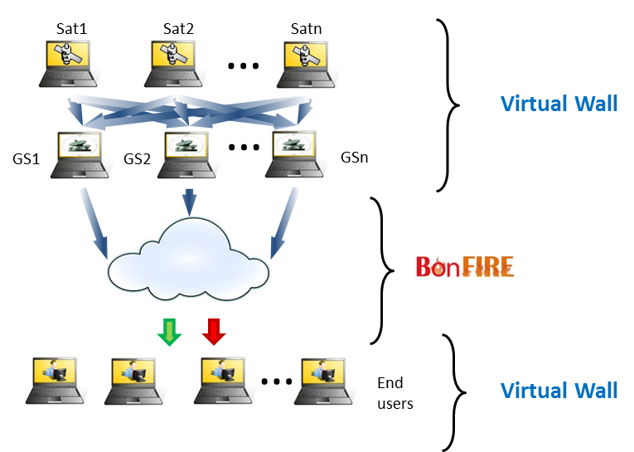

Figure . Relation between BonFIRE and Virtual Wall.

## Architecture

The first approach of the architecture to be implemented in the BonFIRE is constituted of two layers (see Figure 24):

1. **Layer 1:** This layer involves the basic satellite imagery services. It acquires the raw data, has the first level of processing, distributes the processed data, stores the processed data and offers the hosting service. The storage servers will have three functions: i) hosting service for end users, ii) processing of the raw data and required metadata (this data will be stored in a long term basis) and iii) storage of processed data for its later distribution. During the experiment implementation and execution we will define at which levels of processing the images will be stored in cloud. A first approach is to store the raw data and the L1C images, although this strategy can suffer changes.
2. **Layer 2:** This layer involves the high added value services. It can use historical processed data from layer 1. This layer processes the information for real time generation of geo-information and offers real time access and distribution to the end-users. Typically, the implementation of high added value EO services involves the ingestion of the raster imagery from the satellites into a spatial database or storage, where it can be refined, simplified, processed or combined with other data sources in vector or raster format. The products, which can be themselves vector or raster data, are distributed or queried using Internet technologies (OGC standards like WMS, WPS, WCS, CSW, etc. and geo-information servers) or through more pragmatic and efficient mechanisms: REST Web Services, GeoJSON data formats, tiles, caches and Content Delivery Networks (CDN).

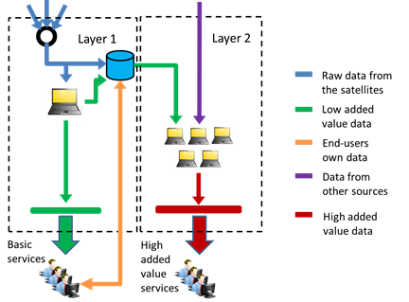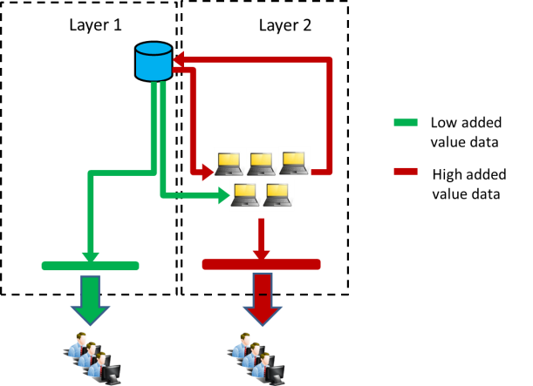

Figure . First approach of the architecture to be implemented in BonFIRE. Two layered EO model in BonFIRE cloud: Cloud model for storage, processing and distribution (left). Short term storage of processed information for its later distribution, postprocessing or both (right).

The architecture depicted in Figure 24 will be evaluated. Then it can suffer modifications during the implementation stage in BonFIRE. In principle this is the strategy:

1. The raw data is received and stored. We will evaluate if it is better to store raw data or images processed at a low level, such as L0.
2. The raw data is processed until an orthorectified image is obtained.
3. The orthorectified image can be directly distributed (we will analyze if this can be done during the implementation and experimentation stages) and stored to be used in high added value services or direct distribution. We will evaluate if the cloud is fast enough to avoid storage of orthorectified images, and process on demand raw data or data processed at a low level, for example L0. Although our first impression is that we will have to store all the orthorectified images for its distribution through high added value services.
4. Data from other sources will be integrated for its distribution.

The modules that constitute the different layers of the architecture are depicted in Figure 25 and they are described as follows:

* **Orchestrator:** it manages the automatic distribution of the raw data to the processors. It handles the complete automatic processing chain execution. If the processor chain is occupied, the manager replicates the complete chain in a new machine.
* **Product Processors:** They process the raw data and convert it in orthorectified images.
* **Archive and catalog:** It is the place where the processed images are stored and cataloged for its distribution.
* **Low added value distribution:** It is the module in charge of the direct distribution of the basic imagery data (orthorectified images), through direct downlink to the users.
* **High added value distribution:** It is the module in charge of the distribution of high added value services generated with the processed data.

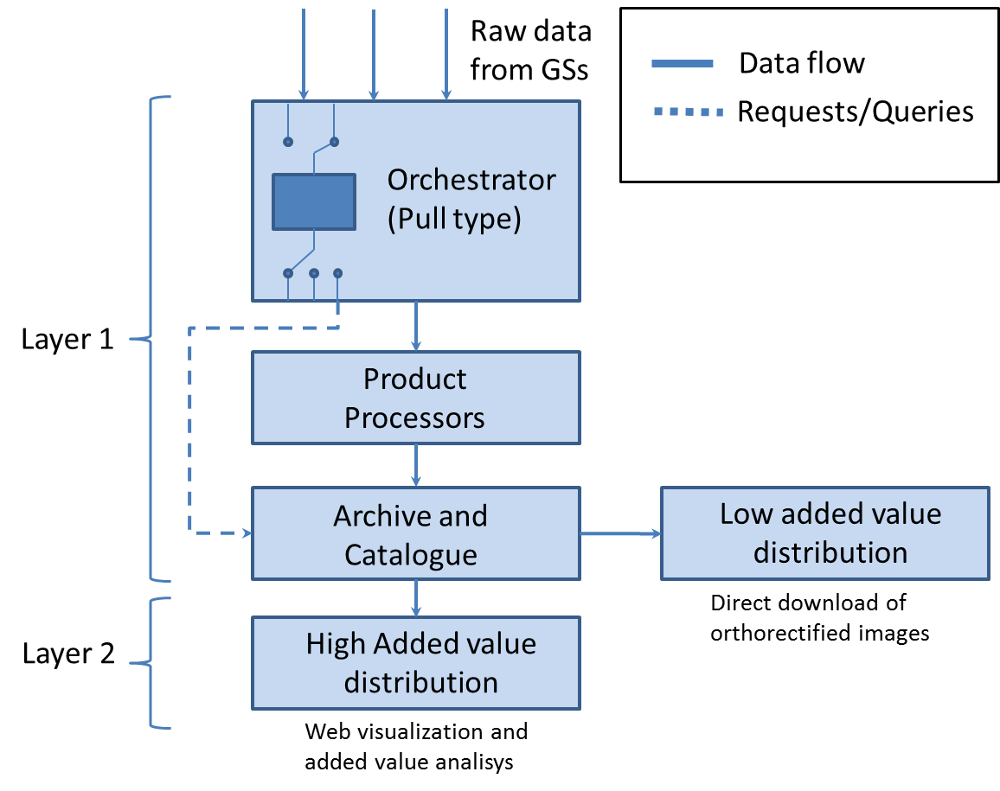

Figure . Data Processing in Cloud.

The data flow is depicted in a numbered sequence as follows:

1. Data Ingestion. Incoming data is ingested into the system. The main source for incoming data is from the satellites. However, there can be other input sources, such as the calibration facility. Depending on the nature of the incoming data, some pre-processing might be required. In all cases, the incoming data is incorporated to the Archive. This operation is directed by the Orchestrator.
2. The Orchestrator, driven by the event of new data ingested, follows a set of rules, or task tables, to initiate the execution of a Processor whenever all the inputs are available. When the input files are all available the Orchestrator circulates them to a (shared <<TBD>>) storage area.
3. Once all the files are ready for processing in the storage area, the Orchestrator prepares a Job Order for the Product Processors. The Job Order contains all the information required by the Processing Facility to process incoming data. The Orchestrator starts and controls the execution of the Processor required to perform the Job Order.
4. The Processor retrieves data from the storage area and performs the required process on the input data, generating output data in the shared storage area. The execution of a Processor is specified in the Job Order. During the execution, the Processor logs the most significant events occurring during the processing.
5. Upon finalization, the Orchestrator moves the produced data into the Archive.
6. From the archive, data can be delivered and transformed into more specific products and value added services though FTP, Web Services, OGC Standard Web Services, etc.

## Orchestrator

The orchestrator has the following functions:

* Understanding of the processors capabilities:
  + Identifies if the input is mandatory or optional
  + It identifies which outputs shall be generated by the processors
* Generating the Job Orders: they contain all the necessary information that the processors need. They include the interfaces and addresses of the folders in which the input information for the processors is located and the folders in which the outputs of the processors have to be sent. They also include the format in which the processors generate their output. They are XML files.
* Reading the configuration of the processor chain to obtain the information about the type of orders that can be attended with their priority and the processors to be launched during all the processing chain.
* Controlling the processors to instruct them to pause, resume and cancel the operation.

The orchestrator receives the information in a pull type manner. It is the input interface to the cloud from the ground stations. The orchestrator is looking at the FTPs that connect the ground stations with the cloud and if there is data it takes it and manages it to the processing chain through Job Orders.

The Orchestrator has to be implemented in a Virtual Machine. From this VM the processing chain is managed.

The following table shows the instance type that is intended to use for the orchestrator.

|  |  |  |  |
| --- | --- | --- | --- |
| **Instance type** | **CPU cores** | **Memory** | **Features** |
| medium | 2 | 2GB |  |

The orchestrator will be ad hoc implemented for BonFIRE as our first option.

## Product Processors

The Product Processors is a module that is in charge of processing the payload raw data from the satellites to produce image products. The four, most important operations that the product processors perform on the input data are the following:

* A calibration, to convert the pixel elements from instrument digital counts into radiance units.
* A geometric correction, to eliminate distortions due to misalignments of the sensors in the focal plane geometry.
* A geolocation, to compute the geodetic coordinates of the input pixels.
* An ortho-rectification, to produce ortho-photos with vertical projection, free of distortions.

The previous steps also generate quality-related figures of merit that are made available in all the products. Moreover, the product processors generate metadata, in line with industry standards, to facilitate the cataloguing, filtering and browsing of the product image collection.

The output image products are classified into four different levels, according to the degree of processing that they have been subjected to (see Figure 26):

* Level 0 products are unprocessed images, in digital count numbers.
* Level 1A products are calibrated products, in units of radiance.
* Level 1B products are calibrated and geometrically corrected products (ortho-rectified), blindly geolocated.
* Level 1C products are calibrated and geometrically corrected products (ortho-rectified), precisely geolocated using ground control points.

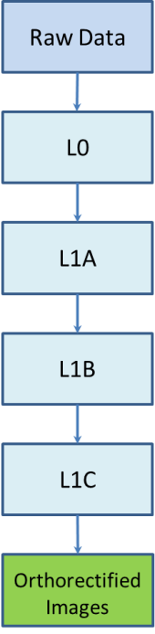

Figure . Stages of product processing.

All the processing chain, i.e., the four processors will be installed in one Virtual Machine. The orchestrator will manage the running of different VMs with the processors replicated for parallel processing of different images at the same time.

The instance type in which the processors will be implemented should have at least the following characteristics:

|  |  |  |  |
| --- | --- | --- | --- |
| **Instance type** | **CPU cores** | **Memory** | **Features** |
| xlarge+ | 4 | 8GB | Higher CPU clock speed (over 3GHz) |

In the scenarios that will be tested in the experiment the worst case is that in which twelve satellites will be downloading data to ground stations simultaneously. Thus twelve nodes with replicated processors will process images simultaneously.

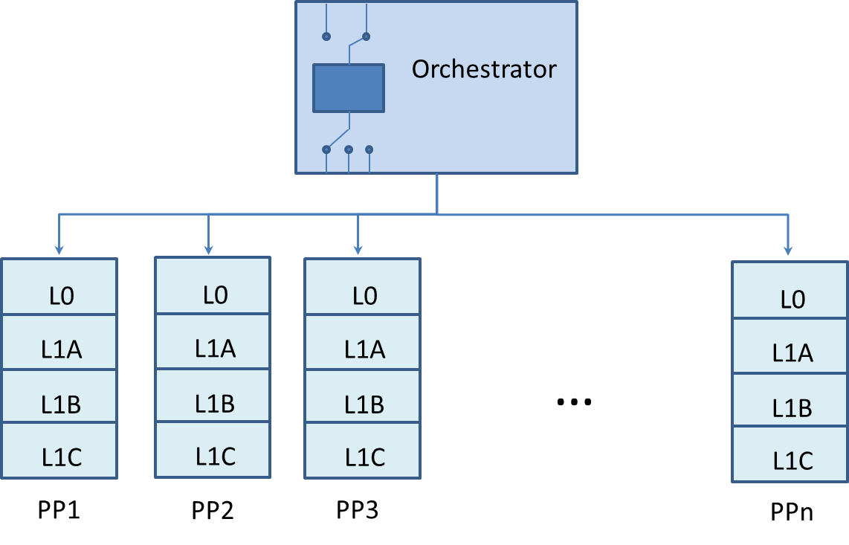

Figure . Scheme of the orchestrator managing different product processors in parallel.

The product processors are four .exe files, one per processing stage. They will be configured via XML files. Not compilation of the software will be required, just interpretation of the configuration files.

The Product Processors software requirements are the following in our premises:

* Linux Operative System
* Virtual environment VMware
* CentOS

For their implementation in BonFIRE we will study the following possibility:

* The implementation of the product processors in the BonFIRE cloud through its interface to automatically and dynamically provision new VMs. This means that the first approach will be not to access the BonFIRE hypervisor as a backend, nor deploying the VMware hypervisor for example in be-ibbt is running physical nodes, and could provide this possibility (Xeon E5645 supports VT-d technology). This implementation will make the system flexible and scalable. Thus the executor will be able of provisioning new instances for an on-demand use of the resources. In conclusion, we will compute the Virtual Machines and we will not deploy VMware.
* In BonFIRE, centOS is a feature not already implemented, although contemplated. Not to depend on this we will run the software on Debian Squeeze.

### The L0 processor

The acquired data is organized into image sectors of predefined size and structure and converted in scenes. Scenes, as defined here, are used throughout the subsequent L1 levels. The size and configuration of the scene is not changed again in the processing chain, for this reason the scene definition is constant for all the L1 levels.

The inputs are the following

* The Raw Data.
* The configuration database.
* The calibration database.

The outputs are the following:

* The L0 products.

### The L1A processor

This section describes the functionality of the processors included in the Level 1A of the Automatic Processing Chain. The goal of Level 1A is to calibrate the scenes. The resulting images are given in units of radiances.

The L1A component works on the scenes that compound the L0 product, performing different transformations over pixel values to generate radiances.

The inputs to the L1A level are:

* One L0 scene.
* The configuration database.
* The calibration database.

The output is:

* The L1A product.

### The L1B processor

Level 1B implements the geolocation, resampling and packing.

The inputs to the L1B level are the following:

* The L1A product.
* The configuration database.
* The calibration database.

The outputs are the following:

* The L1B products.

### The L1C processor

The L1C processor performs the ortho-rectification of the L1B product using ground control points.

The inputs to the L1C level are the following:

* The L1B product.
* The calibration database.
* The configuration database.

The output is the following:

* The L1C products.

## Archive and Catalogue

The archive and catalog is a shared space of memory between the orchestrator, the product processors and the distribution of data. It has a data acquisition component.

**Data Acquisition component**: This component manages the input data arriving to the Archive and Catalog. The ingestion of data is automatic.

In the Archive and Catalog module the processed images will be stored and catalogued for their distribution in both ways direct downloading (low added value services) and web based service (high added value services).

The Archive and Catalog basically consists of:

* The Archive is constituted by optimized storages structure allowing managing a big amount of data, efficient storage and retrieval of any kind of file. The Archive shall be organized in hierarchical levels of storage in order to provide a cost effective storage solution.
* The Catalogue shall store an inventory database with the metadata of archive files. It allows the product process chain easiness to access to the metadata from the processed products.
* For the added value services the catalog will be accessed by a Web Service.
* CSW (Catalog Service for the Web) is a module with the CSW standard for the catalogue (based on OGC standard). For more information on CSW, please refer to [OGC OpenGIS Implementation Specification 07-006r1](http://www.opengeospatial.org/standards/specifications/catalog) and the [OGC tutorial on CSW](http://www.ogcnetwork.net/node/630). Through this standard the distribution of data is done. It communicates with the Archive and Catalog. We intend to use GeoServer and GeoNetwork:

GeoServer: <http://docs.geoserver.org/latest/en/user/extensions/csw/index.html>

GeoNetwork: <http://geonetwork-opensource.org/>

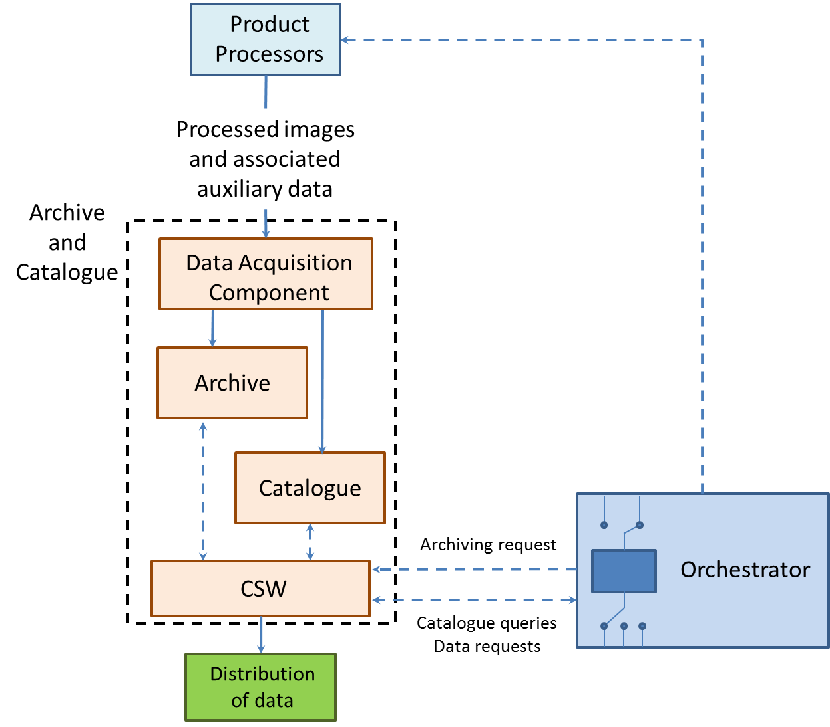

Figure . Scheme of the Archive and Catalogue Module.

Instance required for archive and catalogue:

|  |  |  |  |
| --- | --- | --- | --- |
| **Instance type** | **CPU cores** | **Memory** | **Features** |
| storage | - | TBD |  |

## Imagery Distribution and Visualization

The architecture of the Imagery distribution and visualization was depicted in Section 4. The Archive and Catalog provides the processed satellite images to a raster and a vector datastore that ingest the data into an EO server for its later distribution to the end user. In the following subsections the modules of the architecture will be briefly described. The resources that will be required in BonFIRE are also depicted in tables. More information about imagery distribution and visualization can be found in Section 4.

### Archive and Catalogue

The processed images will be stored and catalogued for their distribution in both ways direct downloading (low added value services) and web based service (high added value services).

### Datastore

The datastore will be fed from the archive and catalogue with the required scenes from the archive. In some cases, additional processing will be needed to optimize these scenes for distribution through OGC Web Services, to populate the tiles cache, etc.

|  |  |  |  |
| --- | --- | --- | --- |
| **Instance type** | **CPU cores** | **Memory** | **Features** |
| storage | - | 300 GB |  |

The datastore will be based on two components:

* A geospatial database, to handle geometries and vector features, and in some cases, raster files. It will be based on PostGIS database.
* The instance filesystem.

### EO Server

A map and feature server for sharing, analyzing, and editing geospatial data from spatial data sources using open standards. It implements OGC Web Services (WMS, WFS, WCS, etc.) as well as providing tiling and cache mechanisms.

For most of its web services, it can be scaled horizontally by adding several EO Server nodes to the infrastructure.

|  |  |  |  |
| --- | --- | --- | --- |
| **Instance type** | **CPU cores** | **Memory** | **Features** |
| xlarge+ | 4 | 8GB | Higher CPU clock speed (over 3GHz) |

|  |  |  |  |
| --- | --- | --- | --- |
| **Instance type** | **CPU cores** | **Memory** | **Features** |
| Load balancer | - | - | EaaS |

### Tiles Caches

For the tiles cache, GeoWebCache will be used. It is s a Java web application used to cache map tiles coming from a variety of sources such as OGC Web Map Service (WMS). It implements various service interfaces (such as WMS-C, WMTS, TMS, Google Maps KML, Virtual Earth) in order to accelerate and optimize map image delivery. It can also recombine tiles to work with regular WMS clients.

GeoWebCache can scale horizontally by adding nodes sharing the same cache data store. To store the cached tiles, high storage capacity is needed.

|  |  |  |  |
| --- | --- | --- | --- |
| **Instance type** | **CPU cores** | **Memory** | **Features** |
| storage | - | 500 GB |  |

|  |  |  |  |
| --- | --- | --- | --- |
| **Instance type** | **CPU cores** | **Memory** | **Features** |
| Custom | 4 | 2GB | Higher CPU clock speed (over 3GHz) |

|  |  |  |  |
| --- | --- | --- | --- |
| **Instance type** | **CPU cores** | **Memory** | **Features** |
| Load balancer | - | - | EaaS |

## Data, control and monitoring parameters

### Data

The data that will be transferred between nodes. It will be images of about 2GB size.

### Control parameters

The control parameters are the inputs from Virtual Wall:

|  |
| --- |
| **BonFIRE control parameters** |
| GS# servers |
| User# clients |

### Monitoring parameters

The monitoring parameters are depicted in the following table:

|  |
| --- |
| **BonFIRE monitoring parameters** |
| Processing time |
| Latency from image capture to distribution |
| Storage load |
| Processing load |
| Processing and storage strategy viability |
| Cues management |
| Performance of the system |

## Data flow and configuration of the nodes

The data flow is the following:

1. The BonFIRE cloud acts as a client to the GS servers in Virtual Wall. Both are interconnected through an FTP.
2. The orchestrator pulls over the “GS#” servers in Virtual Wall if there is data available it is ingested into the processing chain computed in the BonFIRE cloud.
3. Once the data has been processed and images have been stored they are distributed from the BonFIRE cloud servers to the Virtual Wall clients named as “User#”. There are two options:
   1. A User# client pulls over the BonFIRE servers via FTP or SSH and retrieve the data.
   2. A BonFIRE server pushes (transfers) the data over a User# client. It is usually done using Web Services (OGC, REST, HTTP).
4. A hosting service from BonFIRE is also provided to the User# Clients in Virtual Wall.

See Figure 29 for a graphical description of the data flow and configuration of the nodes.

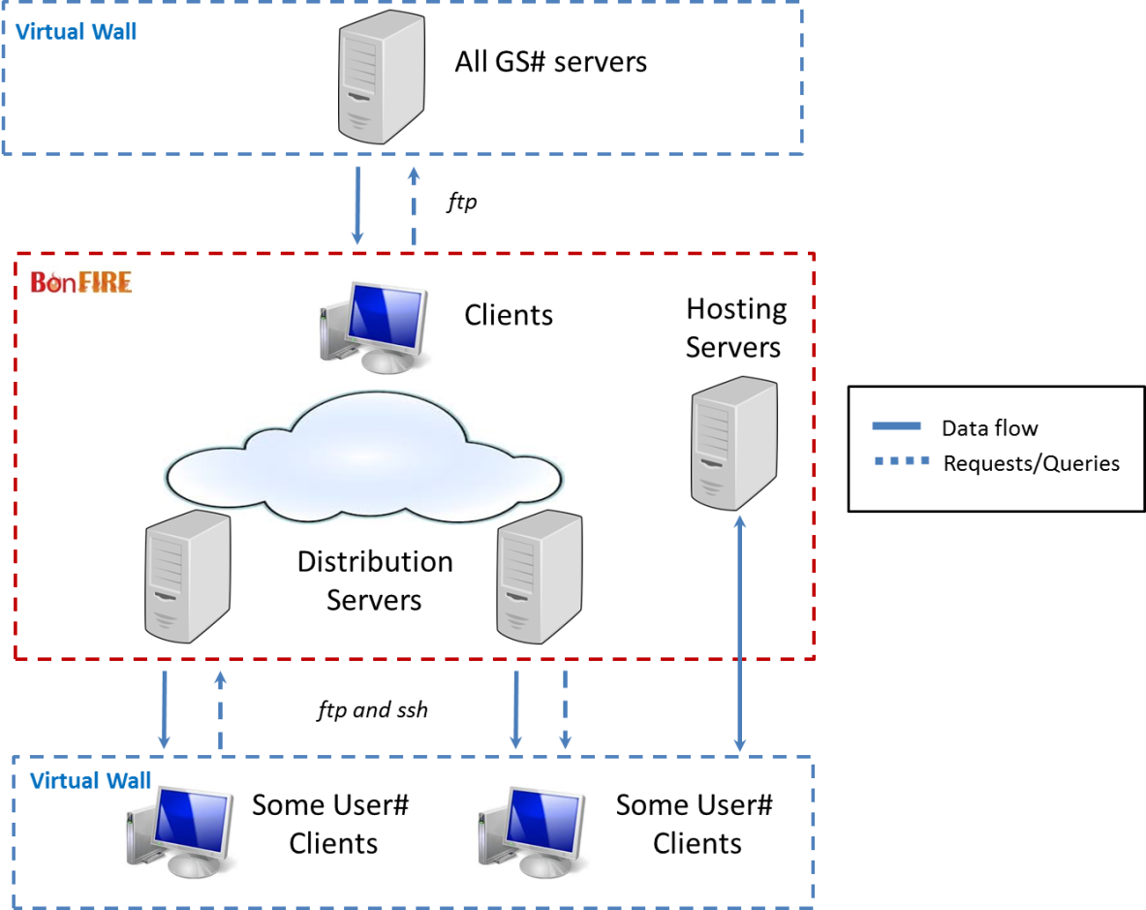

Figure . Data flow and configuration of the nodes.

## Summary

In this document the architecture to be implanted in the BonFIRE cloud has been described. The resources to be used during the implementation and the experimentation were defined. The connectivity between Virtual Wall and BonFIRE were introduced.

The software modules to be installed in BonFIRE and the scripts and software to be developed in order to integrate the experiment were defined.

# Topology Networks in Virtual Wall

In this section the topology networks to be implemented in Virtual Wall for the execution of the GEO-Cloud experiment are designed.

Virtual Wall will communicate with the BonFIRE cloud in two manners:

1. Transferring data from Virtual Machines in Virtual Wall to the BonFIRE cloud.
2. Requesting data to the BonFIRE cloud and receiving it to the Virtual Wall servers.

The option “a” emulates the transfer of data from satellites to ground stations located around the world and such data transferred to the BonFIRE cloud.

The option “b” emulates the requesting of low and high added value GEO-Cloud services from users around the world.

Figure 30 shows the relation between Virtual Wall and BonFIRE.



Figure . Communication between VW and BF.

## Architecture

The system to be implemented in Virtual Wall is constituted by three layers:

* In layer 1: 17 nodes will be used to simulate 17 satellites in orbit.
* In layer 2: 12 nodes will be used to simulate 12 ground stations in which data is transferred from layer 1. The data transferred to layer 2 is transferred to the BonFIRE cloud.
* In layer 3: n (TBD) nodes will be used to emulate n (TBD) users requesting data from the BonFIRE Cloud.

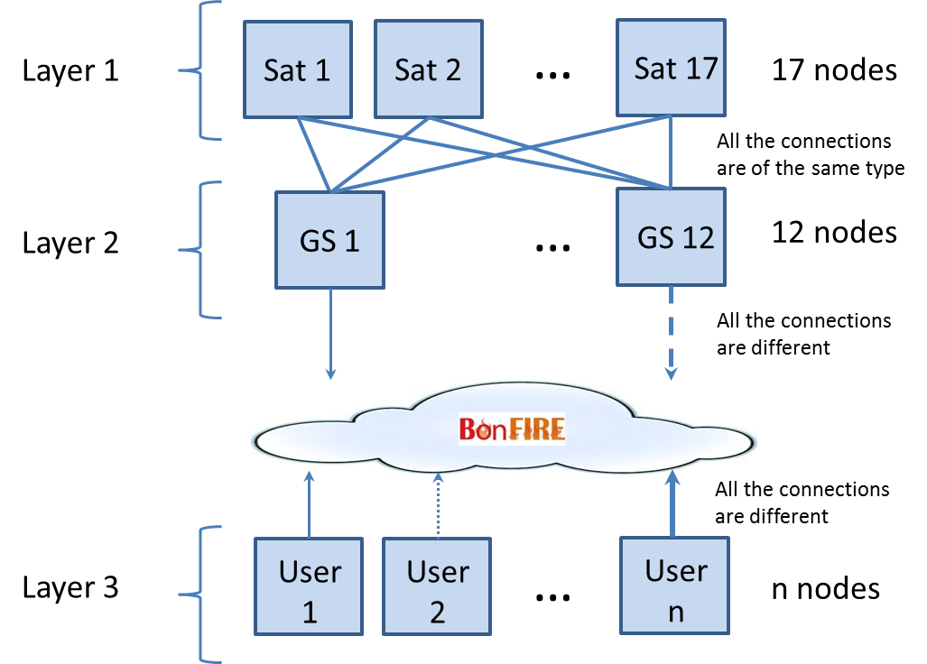

Figure . Architecture implemented in Virtual Wall.

## Layer 1

To constitute the layer 1 we need 17 nodes. In every node a script will be computed to emulate the recordings of a satellite, its orbit and its passes over ground stations.

The data to be transferred from layer 1 to layer 2 will be lower than 60GB. The data to be transferred will be raw data satellite imagery of about 2GB each.

Every Sat node is connected with all the GS nodes. All the links between a Sat node and a GS node have the same features: 160 Mbps bandwidth with impairments (measured in reality with the Deimos’ satellites). In total there are 204 links between the Sat and the GS nodes. Every Sat node is acting as a server and every GS node as a client.

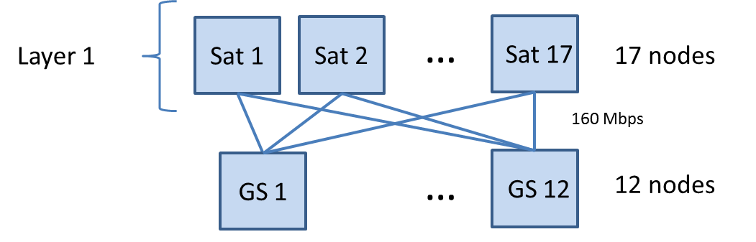

Figure . Layer 1 resources.

We have 17 subnets of the following type:

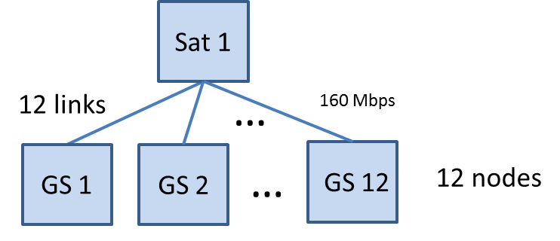

Figure . Subnet between the node Sat1 and the nodes GS1 to GS12.

Resources required for Layer 1:

|  |  |  |  |  |  |
| --- | --- | --- | --- | --- | --- |
| **Nodes & Resources** | **Number** | **Bandwidth** | **Latency** | **Loss Rate** | **Background Traffic** |
| Nodes | 17 | - | - | - | - |
| Resources | 12 | 160Mbps | 2.15ms | 10e-6 | 0 |

Description of the subnets in layer 1:

Subnet 1: 172.16.1.0

Subnet 2: 172.16.2.0

Subnet 3: 172.16.3.0

Subnet 4: 172.16.4.0

Subnet 5: 172.16.5.0

Subnet 6: 172.16.6.0

Subnet 7: 172.16.7.0

Subnet 8: 172.16.8.0

Subnet 9: 172.16.9.0

Subnet 10: 172.16.10.0

Subnet 11: 172.16.11.0

Subnet 12: 172.16.12.0

Subnet 13: 172.16.13.0

Subnet 14: 172.16.14.0

Subnet 15: 172.16.15.0

Subnet 16: 172.16.16.0

Subnet 17: 172.16.17.0

## Layer 2

Layer 2 is constituted by 12 nodes named GS# nodes. Every node is representing a ground station. The ground stations connect with the satellites and receive data. But they also act as servers to transfer the previous data to the BonFIRE cloud. The connectivity between GS# and BonFIRE will be FTP.

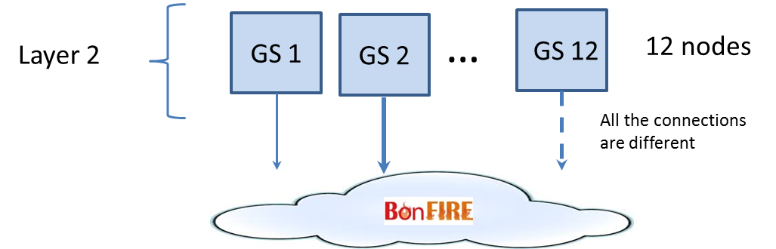

Figure . Layer 2.

We have other 12 subnets, but in this case every GS node has one connection with the cloud.

Resources required for Layer 2:

|  |  |  |  |  |  |
| --- | --- | --- | --- | --- | --- |
| **Nodes & Resources** | **Number** | **Bandwidth** | **Latency** | **Loss Rate** | **Background Traffic** |
| Nodes | 12 | - | - | - | - |
| Resources | 1 | TBD | TBD | TBD | TBD |
| Resources | 1 | TBD | TBD | TBD | TBD |
| Resources | 1 | TBD | TBD | TBD | TBD |
| Resources | 1 | TBD | TBD | TBD | TBD |
| Resources | 1 | TBD | TBD | TBD | TBD |
| Resources | 1 | TBD | TBD | TBD | TBD |
| Resources | 1 | TBD | TBD | TBD | TBD |
| Resources | 1 | TBD | TBD | TBD | TBD |
| Resources | 1 | TBD | TBD | TBD | TBD |
| Resources | 1 | TBD | TBD | TBD | TBD |
| Resources | 1 | TBD | TBD | TBD | TBD |
| Resources | 1 | TBD | TBD | TBD | TBD |

The bandwidth and impairments for each subnet is still TBD, although all of them will be different. In the experiment we will fit initial values for each of them that will later be updated with the measurements we will obtain from real measurements in PlanetLab Europe.

Description of the subnets in layer 2:

Subnet 18: 172.16.18.0

Subnet 19: 172.16.19.0

Subnet 20: 172.16.20.0

Subnet 21: 172.16.21.0

Subnet 22: 172.16.22.0

Subnet 23: 172.16.23.0

Subnet 24: 172.16.24.0

Subnet 25: 172.16.25.0

Subnet 26: 172.16.26.0

Subnet 27: 172.16.27.0

Subnet 28: 172.16.28.0

Subnet 29: 172.16.29.0

## Layer 3

Layer 3 is constituted by n (TBD) nodes (<10 probably) with computed scripts that will be emulating end users loads (requests and data transfer from the BonFIRE cloud). The data transfer can be of two types:

1. Direct download of data through (FTP)
2. Visualization through a web service (HTTP).

Every node will have a defined type of data transfer. They are still TBD.

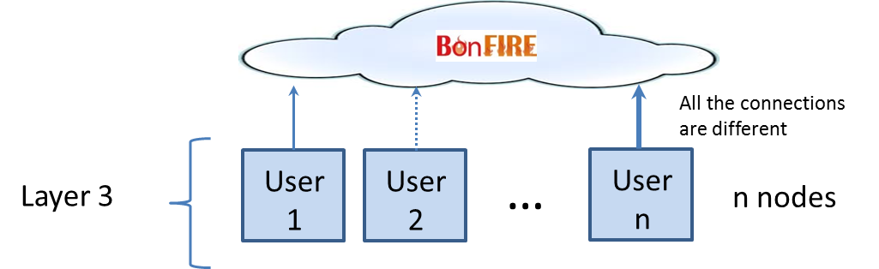

Figure . Layer 3.

Resources required for Layer 3:

|  |  |  |  |  |  |
| --- | --- | --- | --- | --- | --- |
| **Nodes & Resources** | **Number** | **Bandwidth** | **Latency** | **Loss Rate** | **Background Traffic** |
| Nodes | N (TBD <10) | - | - | - | - |
| Resources | 1 | TBD | TBD (from experiments in PlanetLab Europe) | TBD (from experiments in PlanetLab Europe) | TBD (from experiments in PlanetLab Europe) |
| Resources | 1 | TBD | TBD (from experiments in PlanetLab Europe) | TBD (from experiments in PlanetLab Europe) | TBD (from experiments in PlanetLab Europe) |
| … | … | … | … | … | … |
| Resources n | 1 | TBD | TBD (from experiments in PlanetLab Europe) | TBD (from experiments in PlanetLab Europe) | TBD (from experiments in PlanetLab Europe) |

The bandwidth and impairments for each subnet is still TBD, although all of them will be different. In the experiment we will fit initial values for each of them that will later be updated with the measurements we will obtain from real measurements in PlanetLab Europe.

Description of the subnets in layer 3:

Subnet 30: 172.16.30.0

Subnet 31: 172.16.31.0

Subnet 32: 172.16.32.0

…

Subnet n: 172.16.(29+n).0

### Design of L3 for the pre-defined use cases

In this subsection we design the layer 3 to be implemented in Virtual Wall in order to emulate loads of end users accessing and retrieving information from the BonFIRE cloud.

The use cases are defined in the Section 3. They are the following:

1. Scenario 1: Emergencies - Lorca Earthquake (Spain)
2. Scenario 2: Infrastructure monitoring - Affection in railway infrastructures by sand movement in desert areas (Spain)
3. Scenario 3: Land Management – South West of England.
4. Scenario 4: Precision Agriculture – Argentina.
5. Scenario 5: Basemaps – Worldwide.
6. Scenario 6: Online Catalogue / Ordering – Worldwide.

Although during the implementation stage we will evaluate the possibility of including new scenarios for testing.

In the following picture the types of communication between the BonFIRE and Virtual Wall nodes are depicted:

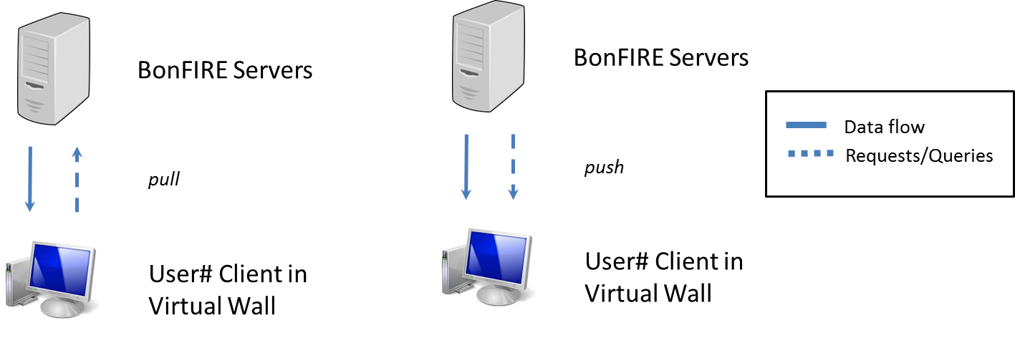

Figure . Types of connectivity between Virtual Wall Layer 3 and BonFIRE nodes.

In the virtual machines created in the VW nodes a script will emulate different loads to simulate accesses to BonFIRE and transfer of data.

#### Design for the Scenario 1 Emergencies - Lorca Earthquake (Spain)

Resources and characteristics required for the deployment of the scenario 1 in Virtual Wall:

* TBD nodes > 5
* Connectivity HTTP and FTP
* Pull type service (see Figure 36).
* Bandwidth: different values for each node in the range of 1Mbps-1Gbps.
* Latency, loss rate and background noise will be obtained from PLE measurements.

#### Design for the Scenario 2 Infrastructure monitoring - Affection in railway infrastructures by sand movement in desert areas (Spain)

Resources and characteristics required for the deployment of the scenario 2 in Virtual Wall:

* 3 nodes
* Connectivity HTTP
* Pull type service (see Figure 36).
* Bandwidth: different values for each node in the range of 1Mbps-1Gbps.
* Latency, loss rate and background noise will be obtained from PLE measurements.

In the virtual machines created in the VW nodes a script will emulate different loads to simulate accesses to BonFIRE and transfer of data.

#### Design for the Scenario 3 Land Management – South West of England.

Resources and characteristics required for the deployment of the scenario 3 in Virtual Wall:

* 1 node
* Connectivity HTTP
* Push type service (see Figure 36).
* Bandwidth: different values for each node in the range of 1Mbps-1Gbps.
* Latency, loss rate and background noise will be obtained from PLE measurements.

#### Design for the Scenario 4 Precision Agriculture – Argentina.

Resources and characteristics required for the deployment of the scenario 4 in Virtual Wall:

* 2 nodes
* Connectivity HTTP for the push service (1 node), FTP for the hosting (1 node).
* Push type service 1 node (see Figure 36) and hosting with the other node.
* bandwidth: different values for each node in the range of 1Mbps-1Gbps.
* Latency, loss rate and background noise will be obtained from PLE measurements.

#### Design for the Scenario 5 Basemaps – Worldwide.

Resources and characteristics required for the deployment of the scenario 5 in Virtual Wall:

* n nodes > 10.
* Connectivity HTTP
* Pull type service (see Figure 36).
* Bandwidth: different values for each node in the range of 1Mbps-1Gbps.
* Latency, loss rate and background noise will be obtained from PLE measurements.

#### Design for the Scenario 6 Online Catalogue / Ordering – Worldwide.

Resources and characteristics required for the deployment of the scenario 6 in Virtual Wall:

* 3 nodes.
* Connectivity HTTP
* Pull type service (see Figure 36).
* Bandwidth: different values for each node in the range of 1Mbps-1Gbps.
* Latency, loss rate and background noise will be obtained from PLE measurements.

## Updating of the networks parameters

The network parameters previously defined: latency, bandwidth, background traffic and loss rate will be measured in real networks implemented in PlanetLab Europe. After measuring them in that testbed, they will be computed in the networks implemented in Virtual Wall. See Figure 37.

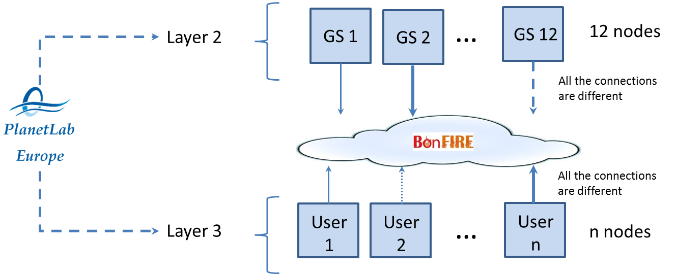

Figure . Update of the networks parameters.

## Data, control and monitoring parameters

### Data

The data that will be transferred between nodes. It will be images of about 2GB size.

### Control parameters

The control parameters are depicted in the following table:

|  |
| --- |
| **Virtual Wall control parameters** |
| Bandwidth |
| Latency |
| Loss rate |
| Background noise |

### Monitoring parameters

The monitoring parameters are the outputs to BonFIRE:

|  |
| --- |
| **Virtual Wall monitoring parameters** |
| BonFIRE clients |
| BonFIRE servers |

## Data flow and configuration of the nodes

The data flow is the following:

1. The Sat# servers store the images and execute the scripts that emulate the GEO-Cloud satellites.
2. The GS# clients request the data from the Sat# servers and it is retrieved.
3. The GS nodes act now as servers and the data is distributed to the BonFIRE cloud. BonFIRE requests the data to the GS# servers and it is transferred.
4. The User# clients in Virtual Wall can be of two types:
   1. The User# client is pulling over the BonFIRE server to retrieve the data.
   2. The BonFIRE server (emulating a subscription) sends the data to the User# client.

Note: Just for clarification, some User# nodes will do pulling, but some others will get the data as if it was a subscription, i.e., BonFIRE will push the data to the User# client.

See Figure 29 for a graphical description of the data flow and configuration of the nodes.

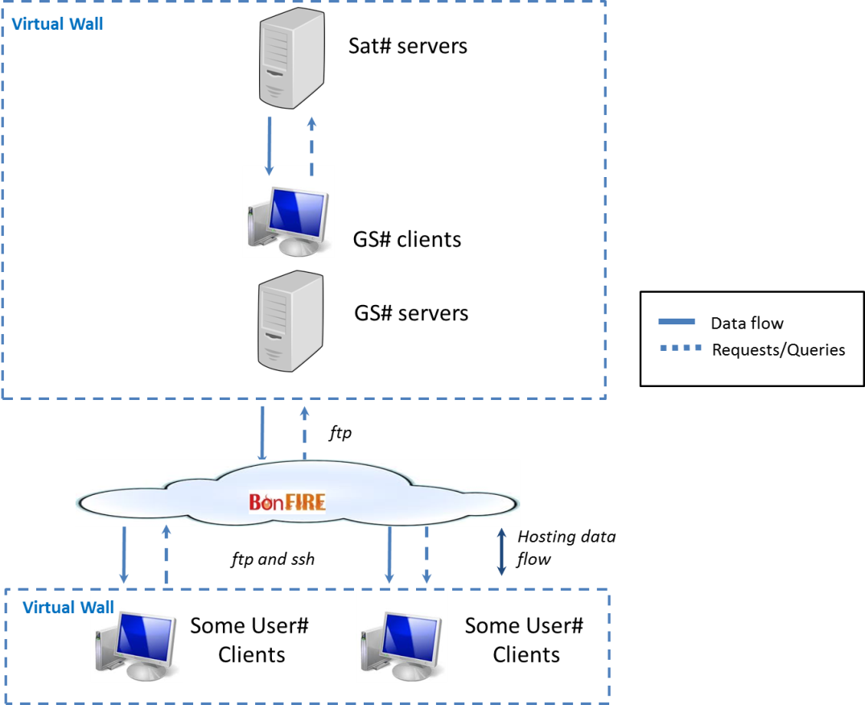

Figure . Data flow and configuration of the nodes.

## Summary

In this document the models to be implemented in Virtual Wall were described and designed for its testing. The resources that will be used for the experiment are defined so as to the connectivity between required between Virtual Wall and BonFIRE.

# Network design in PlanetLab Europe

In this section the topology networks to be implemented in PlanetLab Europe for the execution of the GEO-Cloud experiment are designed.

In Planet Lab Europe two networks will be created:

1. Transferring data from different nodes representing ground stations (GS) to one node representing a cloud node. The first approach is pulling from the cloud node to the GS nodes.
2. Transferring data from a node representing a cloud node to different nodes located around the world representing end users (user node) accessing the cloud. Some of the user nodes will do pulling over the cloud node, some others will receive pushing from the cloud node. (TBD).

In the PLE networks created we intend to measure the following impairments: latency, loss rate, background noise.

In the PLE networks created we intend to control the bandwidth.

The parameters measured and controlled in the PLE networks will be used to update the parameters of the models implemented in Virtual Wall and BonFIRE.

Figure 30 depicts the relation between PlanetLab Europe and Virtual Wall.

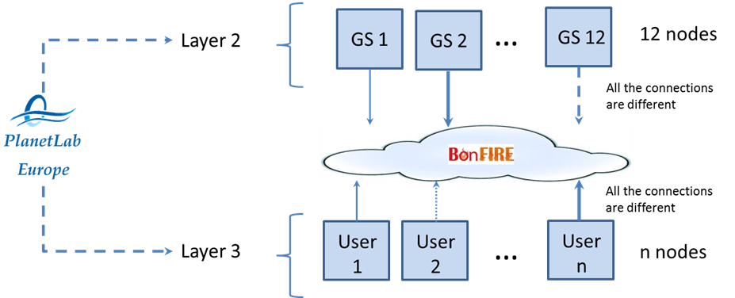

Figure . Relation between PLE, VW and BF.

## Architecture

The system architecture is constituted of two layers:

* Layer 1: Network between ground stations and cloud. 12 nodes located around the world are communicated with one server. The first approach is that the server pulls over the different nodes to receive data from them.
* Layer 2: Network between cloud and end users. In this case a single node emulating a cloud server is connected with different nodes around the world emulating end users accessing the cloud. Some of the nodes emulating end users will pull over the cloud node to receive data. Some others will receive data from the cloud in a push way. The number of nodes that will emulate end users are still TBD.

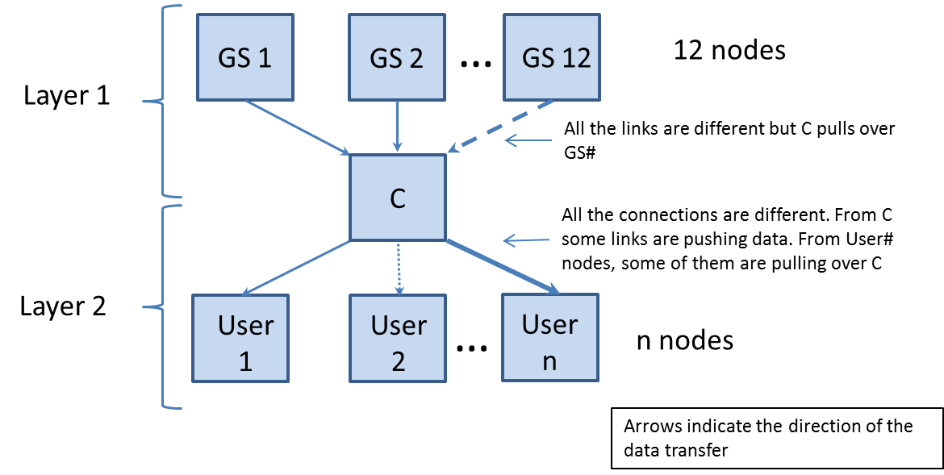

Figure . GEO-Cloud architecture in PlanetLab Europe.

## Layer 1

To constitute the layer 1 we need 12 GS nodes. In every node a script will be computed to configure the node and manage the data that has to be transferred to the C node.

Firstly, we define the nodes that will be used in PLE. They are based in the real locations of the Ground Stations that will be emulated and the BonFIRE cloud.

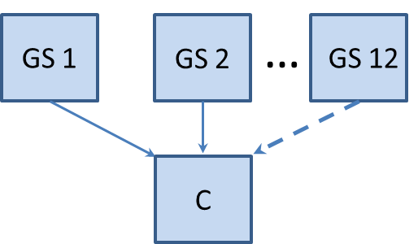

Figure . Layer 1 network scheme.

The real ground stations are depicted in Table 6.

Table . Ground stations.

|  |  |
| --- | --- |
| Ground Station | Location |
| Irkutsk | Russia |
| Puertollano | Spain |
| Svalbard | Norway |
| Troll | Antarctic |
| Chetumal | Mexico |
| Cordoba | Argentina |
| Dubai | United Arab Emirates |
| Kourou | French Guiana |
| Krugersdorp | South Africa |
| Malaysia | Malaysia |
| Prince Albert | Canada |
| Sidney | Australia |

In Figure 42 the ideal location where could be the GS nodes are depicted.



Figure . Location of the GS nodes.

In the following table the GS nodes selected in PLE are depicted:

| Node name | PLE node | Location | Test-bed | website | nodes | slices |
| --- | --- | --- | --- | --- | --- | --- |
| GS-Irkutsk | Beihang University | China | PLC | [http://www.buaa.edu.cn](http://www.buaa.edu.cn/) | 2 | 2 |
| GS-Puertollano | Universidad Carlos III Madrid | Spain | PLE | [www.evalues.es](http://www.planet-lab.eu/www.evalues.es) | 2 | 0 |
| GS-Svalbard | University of Tromso | Norway | PLE | [http://www.cs.uit.no](http://www.cs.uit.no/) | 2 | 0 |
| GS-Troll | PlanetLab Colo - CLARA Santiago | Chile | PLC | - | 2 | 0 |
| GS-Chetumal | University of Puerto Rico at Mayaguez | Puerto Rico | PLC | [http://ece.uprm.edu](http://ece.uprm.edu/) | 2 | 0 |
| GS-Cordoba | Instituto Tecnologico Buenos Aires | Argentina | PLC | <http://www.itba.edu.ar/> | 2 | 0 |
| GS-Dubai | The Hebrew University of Jerusalem | Israel | PLE | <http://www.cs.huji.ac.il/labs/danss> | 2 | 0 |
| GS-Kourou | RNP | Brazil | PLC | [http://rnp.br](http://rnp.br/) | 2 | 0 |
| GS-Krugersdorp | Universite de La Reunion | Reunion Island (France) | PLE | [http://lim.univ-reunion.fr](http://lim.univ-reunion.fr/) | 2 | 0 |
| GS-Malaysia | National University of Singapore | Malaysia | PLC | [http://www.comp.nus.edu.sg](http://www.comp.nus.edu.sg/) | 3 | 3 |
| GS-Prince Albert | University of Saskatchewan | Canada | PLC | [http://usask.ca](http://usask.ca/) | 2 | 0 |
| GS-Sidney | National ICT Australia | Australia | PLE | [http://www.nicta.com.au](http://www.nicta.com.au/) | 2 | 5 |

Some of the previous nodes are not in the same location of the real ground stations. We selected a node near the specific ground station.

The C node will be the following:

|  |  |  |  |  |  |  |
| --- | --- | --- | --- | --- | --- | --- |
| **Node Name** | **node** | **Location** | **Test-bed** | **website** | **nodes** | **slices** |
| Cloud | Universite Pierre et Marie Curie | France | PLE | [http://www.lip6.fr](http://www.lip6.fr/) | 10 | 15 |

The communications between nodes in the Layer 1 in PLE are of pull type through FTP if possible (HTTP or SSH otherwise), i.e, the C client requests retrieving the data from the GS# nodes, see the following figure:

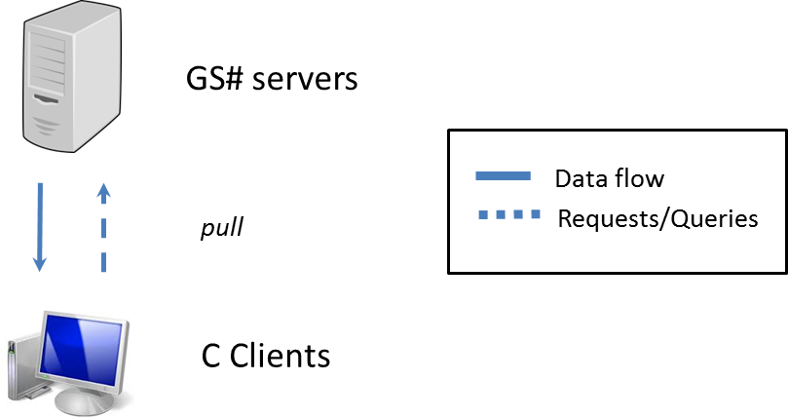

Figure . Types of connectivity between PLE nodes in Layer 1.

## Layer 2

The scheme of the Layer 2 is depicted in the following picture:

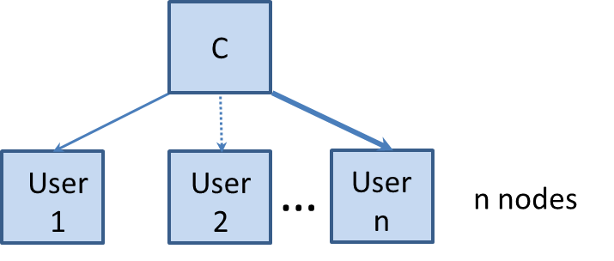

Figure . Layer 2 network scheme.

The C node is the same of the previous case:

|  |  |  |  |  |  |  |
| --- | --- | --- | --- | --- | --- | --- |
| **Node Name** | **node** | **Location** | **Test-bed** | **website** | **nodes** | **slices** |
| Cloud | Universite Pierre et Marie Curie | France | PLE | [http://www.lip6.fr](http://www.lip6.fr/) | 10 | 15 |

The User# nodes will be selected for the scenarios proposed in Section 3:

1. Scenario 1: Emergencies - Lorca Earthquake (Spain)
2. Scenario 2: Infrastructure monitoring - Affection in railway infrastructures by sand movement in desert areas (Spain)
3. Scenario 3: Land Management – South West of England.
4. Scenario 4: Precision Agriculture – Argentina.
5. Scenario 5: Basemaps – Worldwide.
6. Scenario 6: Online Catalogue / Ordering – Worldwide.

Although during the implementation stage we will evaluate the possibility of including new scenarios for testing.

Because we will use NEPI for the provisioning of nodes we will not fix the nodes as done in the previous cases for the GS# and C nodes, we will indicate the country attribute and NEPI will automatically select the available node in that country.

The communications between nodes in the Layer 2 in PLE can be of two types: pull and push, both through HTTP, see next figure:

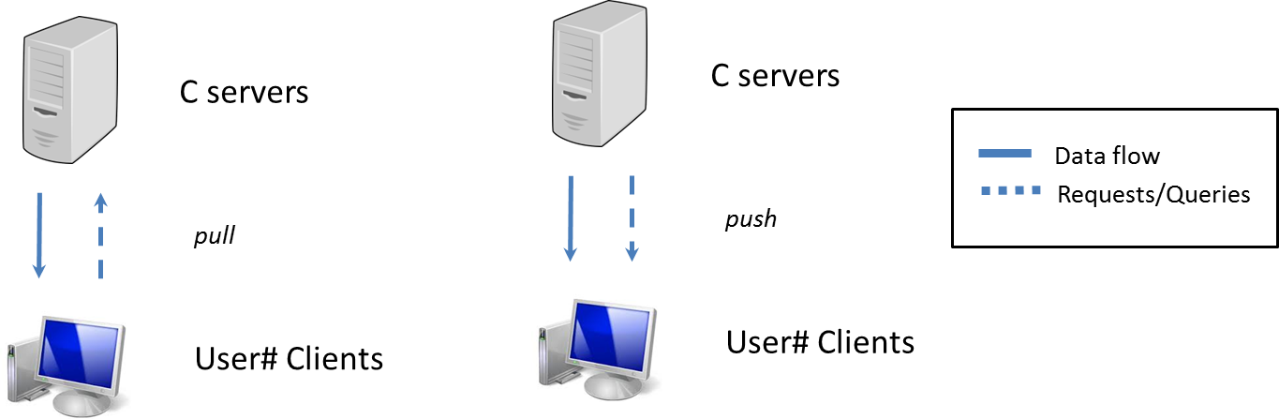

Figure . Types of connectivity between PLE nodes in Layer 2.

The characteristics and number of nodes selected for each scenario are described as follows.

### Design for the Scenario 1 Emergencies - Lorca Earthquake (Spain)

Resources and characteristics required for the deployment of the scenario 1 in PLE:

* TBD nodes > 5
* Pull type service (see Figure 36).
* Countries: Spain, France, UK.

### Design for the Scenario 2 Infrastructure monitoring - Affection in railway infrastructures by sand movement in desert areas (Spain)

Resources and characteristics required for the deployment of the scenario 2 in PLE:

* 3 nodes
* Pull type service (see Figure 36).
* Countries: Spain, Italy, Germany.

### Design for the Scenario 3 Land Management – South West of England.

Resources and characteristics required for the deployment of the scenario 3 in PLE:

* 1 node.
* Push type service (see Figure 36).
* Countries: UK.

### Design for the Scenario 4 Precision Agriculture – Argentina.

Resources and characteristics required for the deployment of the scenario 4 in PLE:

* 2 nodes
* Push type service 1 node (see Figure 36) and push for hosting in other node.
* Countries: Argentina.

### Design for the Scenario 5 Basemaps – Worldwide.

Resources and characteristics required for the deployment of the scenario 5 in PLE:

* n nodes > 10 (TBD).
* Pull type service (see Figure 36).
* Countries: Worldwide.

### Design for the Scenario 6 Online Catalogue / Ordering – Worldwide.

Resources and characteristics required for the deployment of the scenario 6 in PLE:

* 3 nodes.
* Pull type service (see Figure 36).
* Countries: (Australia, USA, Iceland).

## Data, control and monitoring parameters

### Data

The data that has to be transferred between nodes will be images of about 2GB size.

### Control parameters

The parameter that we intend to control is the Bandwidth of the networks.

|  |
| --- |
| **PLE control parameters** |
| Bandwidth |

### Monitoring parameters

The monitoring parameters are depicted in the following table:

|  |
| --- |
| **PLE monitoring parameters** |
| Latency |
| Loss Rate |
| Background noise |

## Data flow and configuration of the nodes

The data flow is the following:

1. The GS servers have the data that has to be transferred to the “Cloud” (C) node (cloud is the name of the node as previously defined). The C node can act as a client to the GS servers and as Servers to the User clients.
2. The C client requests the GS server to retrieve the data and the data is transferred from GS# to C.
3. The data is transferred from the Cloud node to the User# clients. There are two options.
   1. The User# client is pulling over the Cloud server to retrieve the data.
   2. The Cloud server (emulating a subscription) sends the data to the User# client.

Note: Just for clarification, some User# nodes will do pulling, but some others will get the data as if it was a subscription, i.e., the C node will push the data to the User# client.

See Figure 29 for a graphical description of the data flow and configuration of the nodes.

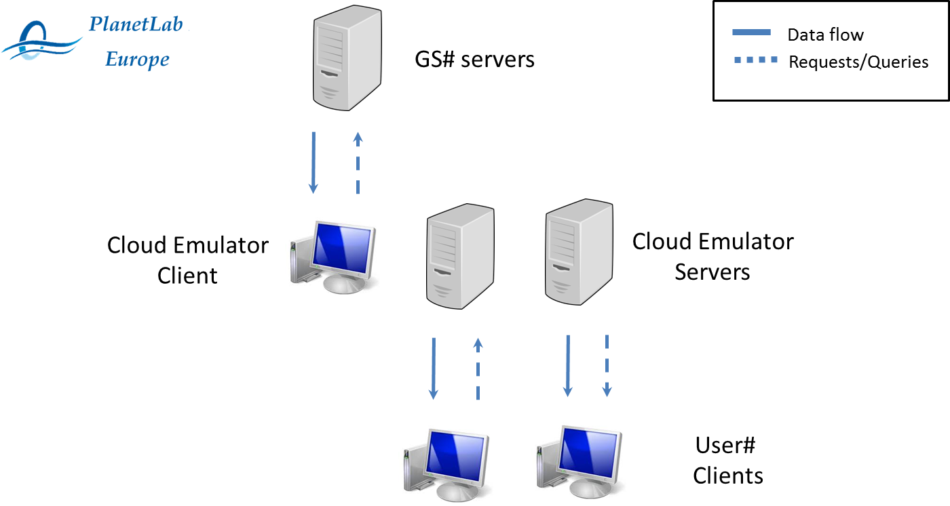

Figure . Data flow and configuration of the nodes.

## Summary

In this document the design of the experiment that will be implemented in PlanetLab Europe is defined. The resources that will be used during the implementation and experimentation were also described so as to the parameters for control and monitoring.

# Bibliography

Amundsen, Bård and Thomas Keilman. "Natural disasters – is your municipality vulnerable?" *Natural disasters – is your municipality vulnerable?* March 2013. <http://www.forskningsradet.no/en/Newsarticle/Natural\_disasters\_\_is\_your\_municipality\_vulnerable/1253984593679?lang=en>.

Astrium. "Precision Agriculture." *Precision Agriculture*. 2013. <http://www.astrium-geo.com/en/1003-precision-agriculture>.

Commission, European. "Examining the creation of a European Border Surveillance System (EUROSUR)." *Examining the creation of a European Border Surveillance System (EUROSUR)*. February 2008. <http://eur-lex.europa.eu/LexUriServ/LexUriServ.do?uri=COM:2008:0068:FIN:EN:PDF>.

Corbane, Christina, et al. "A complete processing chain for ship detection using optical satellite imagery." *International Journal of Remote Sensing*. Taylor \& Francis, 2010. 5837–5854. <http://dl.acm.org/citation.cfm?id=1898618>.

Gardner, Frank. "Seeking Somali pirates, from the air." *Seeking Somali pirates, from the air*. February 2012. <http://www.bbc.co.uk/news/world-middle-east-17095887>.

Hot. *Imagery for Haiyan*. 17 December 2013. <http://hot.openstreetmap.org/updates/2013-12-17\_imagery\_for\_haiyan>.

Instituto Geográfico Nacional, Universidad Complutense de Madrid, Universidad Politécnica de Madrid Instituto Geológico y Minero de España Asociación Española de Ingeniería Sísmica. "Informe del sismo de Lorca del 11 de mayo de 2011." *Informe del sismo de Lorca del 11 de mayo de 2011*. July 2011. <http://www.ign.es/ign/resources/sismologia/Lorca.pdf>.

Lakshmi, Venkat. "Use of Satellite Remote Sensing in hydrological predictions in ungaged basins." *Hydrological Processes*. 2004. 1029–1034. <http://www.isprs.org/proceedings/XXXV/congress/comm1/papers/58.pdf>.

Miller, Steven D., Thomas F. Lee and Robert L. Fennimore. "Satellite-Based Imagery Techniques for Daytime Cloud/Snow Delineation from MODIS." *Journal of Applied Meteorology*. American Meteorological Society, 2005. 987-997. <http://journals.ametsoc.org/doi/pdf/10.1175/JAM2252.1>.

Sandau, Rainer. "Satellite Earth Observation and Surveillance Payloads." *Systems Concepts and Integration Panel*. Ed. NATO. 2009. 16p. <https://www.cso.nato.int/pubs/rdp.asp?RDP=RTO-EN-SCI-209>.

Sensyf. "Services." *Services*. 2013. <http://www.sensyf.eu/services.html>.

Skaugen, Thomas. "Assimilating satellite derived snow covered area (SCA) in hydrological models." *Assimilating satellite derived snow covered area (SCA) in hydrological models*. 2014. <http://undine.bafg.de/servlet/is/15801/>.

# Appendix: Other scenarios

## Scenario 7: Maritime surveillance – Alboran Sea

### Scenario description

The Guardia Civil in Spain is working with Frontex and the European Commission to implement the European Border Surveillance System (EUROSUR) (Commission), see Figure 47. A critical area of the European Frontiers is the Alboran Sea in the south of Spain. In this area thousands of migrants lose their lives try to access the European land from the African coasts.

The Guardia Civil needs daily satellite imagery to detect immigration activity in the emission costs in Africa to start the protocols of the Spanish Maritime Rescue Agency to rescue the migrants’ boats in the Alboran Sea.

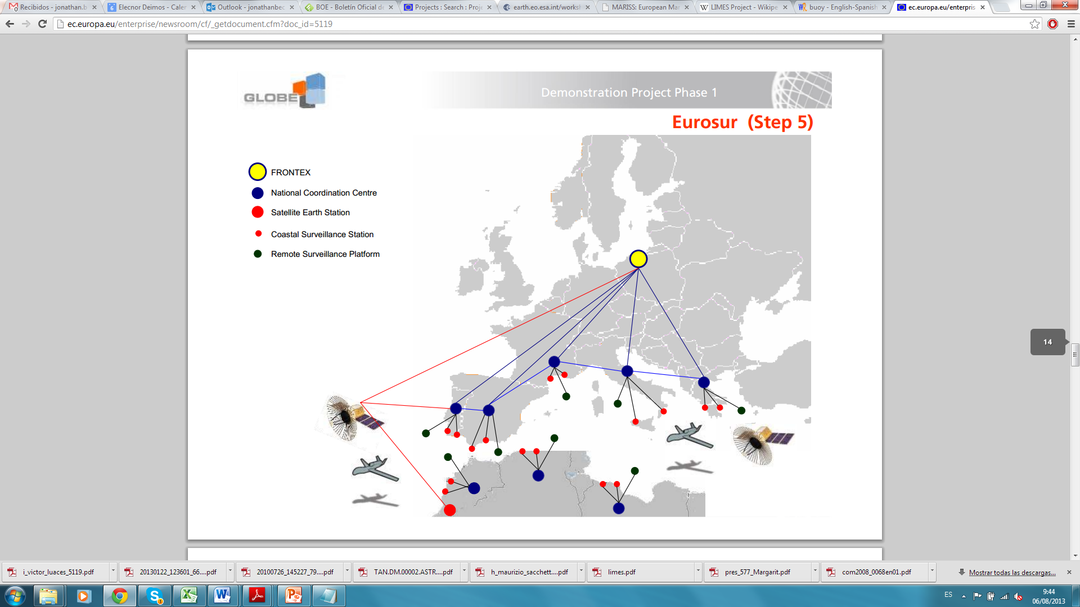

Figure . Eurosur scheme.

### Response

The solicited service is based on the following premises:

* Permanent coverage
* Daily revisit time
* Urgent images
* The images of Alboran Sea should be distributed to the users through a push type service.
* The images require an analysis to identify if there is immigrants activity in the African coast. The analysis consists of probabilistically identifying if there are trucks and dinghies in the beaches.

### Data distribution

To be defined.

### Area of Interest

The Area of Interest is the Alboran Sea in the south of Spain, see Figure 48.

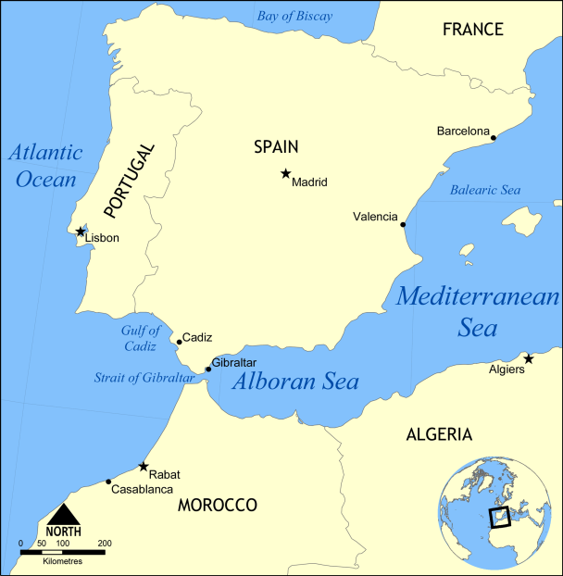

Figure . Alboran Sea Location (image from http://upload.wikimedia.org).

### Users

The users are Guardia Civil, Maritime Rescue Agency and the European Commission.

### Service Type

The service type is high added value of a push type.

### Processing Level

The processing level is low.

### Storage Level

The storage level is high, since images of the Alboran Sea have to be daily recorded and stored.

### Communications Level

The communication level is urgent.

### Demand Variability

The demand variability is constant. See Table 18 for a summary of the service characteristics.

Table . Relation of the users demand with the service offered in the Scenario 7. In orange the characteristics of the service.

|  |  |  |  |  |  |  |
| --- | --- | --- | --- | --- | --- | --- |
|  | **Service Type** | | **Loads in Cloud Technology** | | **Demand Variability** |  |
| **COMPANY'S SERVICES** | Basic | Basic | Processing | Low | Constant | **USERS' DEMAND** |
| Medium |
| Advanced | High |
| Storage | Low | Variable |
| High added value | Pull | Medium |
| High |
| Push | Communications | Not urgent | Highly variable |
| Urgent |
| Hosting | |

## Scenario 8: Homeland Security - Lisbon

### Scenario description

Portugal Government and Lisbon City Council are looking to [remote sensing](http://www.satimagingcorp.com/services.html) and [GIS](http://www.satimagingcorp.com/svc/gismapping.html) to support a security initiative for the city of Lisbon for both strategic planning and for actual tactical deployment during a disaster, see Figure 49.

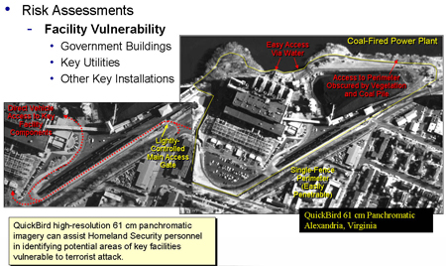

Figure . Example of homeland security analysis (image from DigitalGlobe).

### Response

Portugal Government and Lisbon City Council require an analysis of the Lisbon city for their security initiative.

The analysis includes the following requirements:

* Recent image of the Lisbon city at medium and high resolution.
* Combination of satellite imagery with other sensors (airborne, UAVs, …)
* Orthorectified topographic base map of the city
* Different layers for online visualization
* Critical infrastructures risk assessment (Port, railway, highway, bridges, telecommunications, energy systems, banking and finance, water supply systems, emergency services…)
* Identification of facilities susceptible to attack
* Include multiple information types in different layers

### Data distribution

To be defined.

### Area of Interest

The Area of Interest is the city of Lisbon in Portugal, see Figure 50.

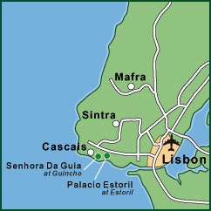

Figure . Lisbon location and area of interest (image from [http://www.captivatingportugal.com](http://www.captivatingportugal.com/)).

### Users

The user is the Portuguese Government.

### Service Type

The service type is high added value.

### Processing Level

The processing level is low.

### Storage Level

The storage level is low.

### Communications Level

The communication level is not urgent.

### Demand Variability

The demand is variable. See Table 19 for a summary of the service characteristics.

Table . Relation of the users demand with the service offered in the Scenario 8. In orange the characteristics of the service.

|  |  |  |  |  |  |  |
| --- | --- | --- | --- | --- | --- | --- |
|  | **Service Type** | | **Loads in Cloud Technology** | | **Demand Variability** |  |
| **COMPANY'S SERVICES** | Basic | Basic | Processing | Low | Constant | **USERS' DEMAND** |
| Medium |
| Advanced | High |
| Storage | Low | Variable |
| High added value | Pull | Medium |
| High |
| Push | Communications | Not urgent | Highly variable |
| Urgent |
| Hosting | |

## Scenario 9: Hydrology – Snow, lake cover in Norway

### Scenario description

A major cause of flooding in Norway is the combination of intense snowmelt and precipitation. In order to be able to forecast these flooding events, a reliable forecast of precipitation and temperature, and a good estimate of the snow reservoir and its coverage in the catchment are required at the time of the forecast.

The snow cover area (SCO) has to be modelled. The SCO is an input to the rainfall run-off model to analyse the dynamics of the snow melt in spring. From the SCO, the snow water equivalent (SWE) is developed. The evolution of this model allows authorities to forecast floods, avalanche and landslides and then start the alert protocols for the evacuation of the population in rural areas in the North of Norway (Skaugen), (Amundsen y Keilman), (Miller, Lee y Fennimore), (Lakshmi).

### Response

The Norwegian Meteorological Institute in Norway requires remote sensing images to monitor the snow evolution, lake cover and water reserves in the Northern Region of Norway.

The satellite imagery required is the following:

* Daily images of the specified AOI.

The Norwegian Meteorological Institute will use the images to

* Differentiate areas with clouds from areas with snow.
* Obtain the Snow cover area
* To obtain the Snow Water Equivalent
* Monitor the water reserves

In Figure 51 an example of the application is shown.



Figure . (left) Visible image, (middle) version-1 snow/cloud enhancement, and (right) corresponding NOAA/NESDIS snow product (from (Miller, Lee y Fennimore)).

### Data distribution

To be defined.

### Area of Interest

The Area of Interest is the north of Norway. See the red coloured area in Figure 52.

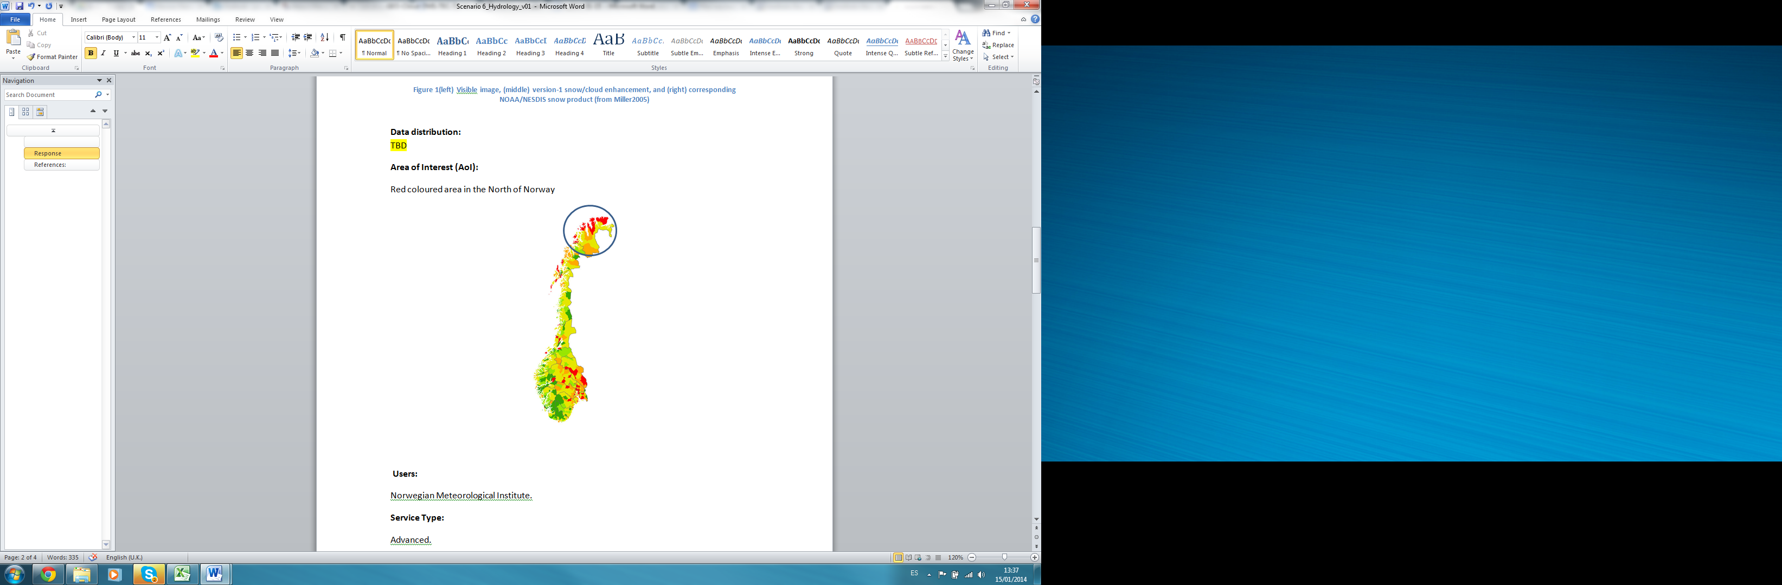

Figure . Area of interest in Norway (from (Amundsen y Keilman)).

### Users

The user is the Norwegian Meteorological Institute.

### Service Type

The service type is advanced.

### Processing Level

The processing level is medium.

### Storage Level

The storage level is medium.

### Communications Level

The communication level is high.

### Demand Variability

The demand variability is constant. See Table 20 for a summary of the service characteristics.

Table . Relation of the users demand with the service offered in the Scenario 9. In orange the characteristics of the service.

|  |  |  |  |  |  |  |
| --- | --- | --- | --- | --- | --- | --- |
|  | **Service Type** | | **Loads in Cloud Technology** | | **Demand Variability** |  |
| **COMPANY'S SERVICES** | Basic | Basic | Processing | Low | Constant | **USERS' DEMAND** |
| Medium |
| Advanced | High |
| Storage | Low | Variable |
| High added value | Pull | Medium |
| High |
| Push | Communications | Not urgent | Highly variable |
| Urgent |
| Hosting | |

## Scenario 10: Hosting for scientists

### Scenario description

The Institut de Recherche pour le Développement in Montpellier, France, is asking for basic images from the satellites to test their Earth Observation algorithms to detect clouds and eliminate them from the images (Corbane, Najman y Pecoul). They ask for basic images from catalog in a variable basis. Because they do not have facilities to store the generated data they need to contract a hosting service in the cloud.

### Response

Services required

* Basic images for downloading
* Hosting service

### Data distribution

To be defined.

### Area of Interest

Images from catalogue.

### Users

Scientists, Institut de recherche pour le Développement.

### Service Type

The service type is hosting

### Processing Level

The processing level is N/A.

### Storage Level

The storage level is low.

### Communications Level

The communication level is not urgent.

### Demand Variability

The demand variability is variable. See Table 21 for a summary of the service characteristics.

Table . Relation of the users demand with the service offered in the Scenario 10. In orange the characteristics of the service.

|  |  |  |  |  |  |  |
| --- | --- | --- | --- | --- | --- | --- |
|  | **Service Type** | | **Loads in Cloud Technology** | | **Demand Variability** |  |
| **COMPANY'S SERVICES** | Basic | Basic | Processing | Low | Constant | **USERS' DEMAND** |
| Medium |
| Advanced | High |
| Storage | Low | Variable |
| High added value | Pull | Medium |
| High |
| Push | Communications | Not urgent | Highly variable |
| Urgent |
| Hosting | |

## Scenario 11: Piracy – Africa Horn (Somalian Coast)

### Scenario description

Some international agencies such as the [International Maritime Organization](http://en.wikipedia.org/wiki/International_Maritime_Organization), [World Food Programme](http://en.wikipedia.org/wiki/World_Food_Programme) and United Nations are asking for daily images of the African Horn to monitor the vessels that navigate around the Somalian Coast.

Piracy has a strong economic impact. According to another source, there were 151 attacks on ships in 2011, compared with 127 in 2010 – but only 25 successful hijacks compared to 47 in 2010. Pirates were holding 10 vessels and 159 hostages in February 2012. In 2011, pirates earned $146m, an average of $4.87m per ship. An estimated 3,000 to 5,000 pirates operated; by February 2012 1,000 had been captured and were going through legal processes in 21 countries (Gardner).

### Response

Services required:

* Daily images of the Area of Interest
* High added value images that include detection of vessels.
* Report of suspicious activity

### Data distribution

To be defined.

### Area of Interest

The Area of Interest is the Somalian Coast, see Figure 53.

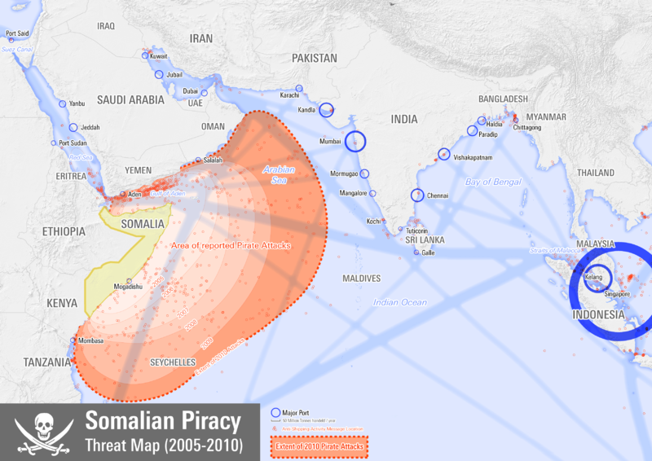

Figure . Somalian coast and area in which piracy is very active (image from <http://en.wikipedia.org/wiki/Piracy_in_Somalia>).

### Users

The users are the [International Maritime Organization](http://en.wikipedia.org/wiki/International_Maritime_Organization), the [World Food Programme](http://en.wikipedia.org/wiki/World_Food_Programme) and the United Nations.

### Service Type

The service type is high added value.

### Processing Level

The processing level is medium.

### Storage Level

The storage level is high.

### Communications Level

The communication level is urgent.

### Demand Variability

The demand variability is constant. See Table 22 for a summary of the service characteristics.

Table . Relation of the users demand with the service offered in the Scenario 11. In orange the characteristics of the service.

|  |  |  |  |  |  |  |
| --- | --- | --- | --- | --- | --- | --- |
|  | **Service Type** | | **Loads in Cloud Technology** | | **Demand Variability** |  |
| **COMPANY'S SERVICES** | Basic | Basic | Processing | Low | Constant | **USERS' DEMAND** |
| Medium |
| Advanced | High |
| Storage | Low | Variable |
| High added value | Pull | Medium |
| High |
| Push | Communications | Not urgent | Highly variable |
| Urgent |
| Hosting | | Urgent |